**PROJECT MANAGEMENT PLAN**

**SurveiRams**

**Asia Pacific College**

**3 Humabon Place, Magallanes**

**Makati City, 1232 Metro Manila**

**APRIL 2023**

TABLE OF CONTENTS

1. Company Profile 5

2. Business Case 6

2.1. Problem Definition 6

2.1.1. Problem Statement 6

2.1.2. Organizational Impact 7

2.1.3. Technology Migration 7

2.2. Project Overview 8

2.2.1. Project Description 8

2.2.2. Goals and Objectives 8

2.2.3. Project Performance 10

2.2.4. Project Assumptions 10

2.2.5. Project Constraints 11

2.2.6. Major Project Milestones 11

2.3. Strategic Alignment 12

2.4. Cost and Benefit Analysis 14

2.3. Strategic Alignment 17

2.4. Cost and Benefit Analysis 18

3. Project Charter 20

3.1. Project Purpose/Justification 20

3.1.1. Business Need 20

3.1.2. Business Objectives 21

3.2. Project Description 21

3.2.1. Project Objectives 23

3.2.2. Success Criteria 23

3.2.3. Requirements 23

3.2.4. Constraints 24

3.2.5. Assumptions 24

3.2.6. Preliminary Scope Statement 25

3.3. Risks 26

3.4. Project Key Deliverables 27

3.5. Summary Milestone Schedule 27

3.6. Budget Summary 28

3.7. Project Approval Requirements 28

4. Project Management Approach 29

5. Project Technical Approach 29

5.1. Product Development Methodology 29

5.2. Technical Architecture 30

6. Project Management Plans 31

6.1. Stakeholders Strategy Management Plan 31

6.1.1. Introduction 31

6.1.2. Identify Stakeholders 32

6.1.3. Key Stakeholders 33

6.1.4. Stakeholder Analysis 34

6.2. Scope Management Plan 36

6.2.1. Introduction 36

6.2.2. Scope Management Approach 38

6.2.3. Roles and Responsibilities 38

6.2.4. Scope Definition 39

6.2.5. Project Scope Statement 39

6.2.6. Work Breakdown Structure 41

6.2.7. Scope Verification 43

6.2.8. Scope Control 43

6.3. Cost Management Plan 44

6.3.1. Cost Management Approach 45

6.3.2. Measuring Project Costs 46

6.4. Schedule Management Plan 58

6.5. Staffing Management Plan 63

6.6. Change Management Plan 72

6.7. Communications Management Plan 81

6.8. Quality Management Plan 93

6.9. Risk Management Plan 101

6.10. Procurement Plan 105

6.11. Implementation Plan 113

7. Sponsor Acceptance 123

8. List of Tables 124

9. List of Figures 124

10. Appendices 125

10.1. Project Cost and Benefit Analysis 125

10.2. Project Methodology 125

10.3. System Requirements Specifications 126

10.4. Development Tools Specification 128

10.5. WBS Dictionary 129

10.6. ..... Detailed Schedule ................................................................................................................. 114

10.7. ..... Detailed Cost Estimates ........................................................................................................ 115

10.8. .....Handle Time .......................................................................................................................... 116

# 1. Company Profile

|  |  |
| --- | --- |
| **Registered Name:** | KAYVI byte |
| **Company Logo:** |  |
| **Address:** | TripleTech Bldg., 190 Doña Soledad Ave, Parañaque, 1709 Metro Manila |
| **Telephone Numbers:** | 551-3390 |
| **Fax Number:** | None |
| **Line of Business:** | Software Development |
| **Type of Customers:** | Home and Business customers |
| **Date of Registration:** | 2021 (KAYVI Byte)  2026 (KAYVI Byte) |
| **President:** | Ian Christopher Onrubia |
| **Number of Employees:** | more than 200 (as of June 4, 2023, in Philippines) |

*Table 1—1: High-level Company Information*

**Introduction:**

Innovative software development firm KAYVI Byte focuses on offering cutting-edge solutions for companies of all sizes. We are dedicated to providing our customers with high-quality, reliable, and effective software products that enable them to improve their operations, streamline procedures, and accomplish their business goals. With a team of highly skilled professionals and a customer-centric approach, KAYVI Byte is dedicated to transforming ideas into reality and driving digital success for our clients.

**Mission:**

At KAYVI Byte, our goal is to use our knowledge in software development to build specialized solutions that address each client's particular requirements. By providing great goods that go above and beyond expectations, maximize productivity, and stimulate corporate growth across industries, we work to establish long-term connections.

The vision, mission, and values of KAYVI byte:

**Vision:**

Our mission at KAYVI Byte is to revolutionize the digital environment by creating cutting-edge software solutions. By providing organizations with cutting-edge technology that foster growth, efficiency, and outstanding user experiences, we hope to establish ourselves as a reliable partner.

**Mission:**

Our mission at KAYVI Byte is to leverage our expertise in software development to create custom solutions that cater to the unique needs of our clients. We strive to build long-term relationships by delivering exceptional products that exceed expectations, maximize efficiency, and drive growth for businesses across industries.

**Values:**

* Adaptable: We are adaptable to change, technology are evolving fast and we are also adapting to the trends of the technological world.
* Growth: We have a passion for growth, we are striving that everyone of us is growing even in the workplace.
* Excellency: We strive fo excellency which surpass expectations.
* Innovation: We foster a culture of innovation constantly explorting new technologies.
* Continuous Learning: We are committed to continues learning even in the professional setting.

# 2. Business Case

### 2.1. Problem Definition

#### 2.1.1. Problem Statement

The process of handwritten reports can be tedious and time-consuming, leading to inefficiency and errors in the documentation process. This can result in a lack of clarity and accessibility to important information for stakeholders such as managers and other employees who require accurate data in a timely manner. The current system also has unnecessary steps that could be eliminated when digitized such as rewriting the information from the logbook onto an incident report to be submitted to the Information Technology Resource Office (ITRO) or Building Maintenance Office (BMO).

#### 2.1.2. Organizational Impact

SurveiRams facilitate the digitization of work processes by reducing the use of paper among employees. Security personnel quickly report incidents they encounter, which allows for a faster response time and enhances overall safety measures within the organization. BMO and ITRO faculty members will also receive the incident reports as soon as a guard logs it, instead of waiting for the rewritten version.

#### 2.1.3. Technology Migration

In order to address the issues brought on by the manual administration of security personnel, BMO, and ITRO, the team will develop a mobile application called SurveiRams that automates the manual documentation procedure. The migration from manual administration to SurveiRams will improve the overall efficiency and accuracy of the security personnel reporting process. As the data will be securely stored and easily accessible to the cloud, it will enable faster decision-making and reduce the risk of errors or discrepancies in reporting.

## 2.2. Project Overview

#### 2.2.1. Project Description

This project will be concerned with the creation of a mobile application for the security personnel and several offices of APC, wherein they can log and view incident reports. This is to digitize the security personnel’s recording process, as well as boost their productivity. There will be different accessible features available depending on the user, which is based on what office or department they are from.

#### 2.2.2. Goals and Objectives

The main goal of this project is to create SurveiRams, a ticketing mobile application for APC’s security personnel, ITRO, and BMO.

Specifically, said application should:

* Serve as a centralized location that the guards will log their patrols on
* Digitize the manual documentation processes of Security, ITRO, and BMO
* Assist users in making decisions by providing insights based on data collected

#### 2.2.3. Project Performance

The mobile application SurveiRams must have the following features for the project to be successful:

1. A repository wherein the user has the ability to create, read, and update incident report and logs.
2. A dashboard where an administrator is able to view insights drawn from the stored data from the reports. The following information should be seen on the dashboard:
3. How many resolved and unresolved incident reports there are
4. The department and floor that ranks highest with regard to the number of incidents that occurred
5. What kind of incident occurred the most
6. How many incidents occurred per floor
7. How many incidents are reported per office

#### 2.2.4. Project Assumptions

Below are the initial expectations about the proposed system:

1. Resources requested in the Cost Management Plan will be provided.
2. The project team have the skills required to complete the project
3. Stakeholders will provide necessary information to the project team regarding their current system and business needs.
4. Relevant stakeholders will cooperate with the team during training and implementation.

The project team is using a Hybrid Methodology (Agile mixed with Waterfall).

#### 2.2.5. Project Constraints

#### 2.2.6. Major Project Milestones

To guide the team’s progress in completing the project, the following milestones and deliverables for this project have been identified:

* Set up a preliminary meeting with Mir Tolentino, Project Manager of Incident Management Department to discuss the initial system requirements and status of the existing technologies by February 1st.
* Conduct the analysis phase and present findings to the primary stakeholder by February 28th.
* Complete the design phase and present mockup design to the primary stakeholder by March 31st.
* Develop the features outlined during analysis and design stages using the resources provided by TELUS and implement the agreed upon user interface by

July 31st.

Achieve a simulated solution which allows no security breaches and complete testing by August 31st.

* Implement system through the VDI environment and disseminate necessary jobaides and documentation through SMEs should be completed by September

15th.

* Conduct a close out meeting and provide hand-off documents to key stake holders before September 30th.

## 2.3. Strategic Alignment

By aligning the Dispatch Directory System project with the overall strategic goals and objectives of TELUS International Digital Solutions in Philippines, the organization will be able to maximize the value of the project and ensure that it is contributing to the longterm success of the company.

**TELUS aims to be the leading provider of telecommunications services in the**  **Philippines.**

The system project aligns with this goal by improving the efficiency and effectiveness of the Cable Repair Escalations Support Team (CREST) and helping enhance the company's reputation as a reliable, high-quality service provider. By streamlining the dispatch process and providing accurate and reliable information, the project will contribute to the overall success of the organization and help it to achieve a competitive advantage in the market.

**TELUS aims to continuously innovate and improve our services in order to meet the changing needs of our customers.**

The system project aligns with this goal by modernizing and streamlining the dispatch process, which will allow CREST team members to effectively track and manage their work and efficiently respond to customers’ (technicians and managers) inquiries. By introducing innovative technologies and processes, the project will help the organization to stay ahead of the curve and remain competitive in an ever-changing market.

**TELUS aims to enhance the satisfaction and loyalty of our customers through exceptional service and support.**

The project aligns with this goal by improving the accuracy and reliability of the dispatch process, which will help minimize delays and confusion and ensure that technicians and managers are deployed correctly. By delivering a higher level of service and support, the project will contribute to the satisfaction and loyalty of customers.

## 2.4. Cost and Benefit Analysis

The cost-benefit analysis will help determine the potential benefits of the Dispatch Directory System project in comparison to the costs incurred. The primary benefit of this project is the improvement in efficiency and accuracy in the dispatch process. The Dispatch Directory System will allow for real-time updates and faster response times, leading to improved customer satisfaction and reduced operational costs.

**Benefits:**

Below are the identified benefits that the project can bring once fully implemented:

* Improved efficiency and effectiveness of the Cable Repair Escalations Support Team resulting in cost and improved outage restoration efforts.
* Improved accuracy and reliability of the dispatch process, resulting in fewer invalid truck rolls and crew deployments which accounts for an average of CAD 3660 loss per month.
* Enhanced customer satisfaction and loyalty due to improved service and support which could result in higher revenue eventually.
* Improved visibility into the work of the CREST team members, enabling managers to monitor the progress of outages and identify potential issues related to dispatch more easily.
* Streamlined and modernized dispatch process, enabling the organization to stay competitive in an ever-changing market.
* Improved user experience across team members of CREST by reducing the time spent processing an action or request.

**Costs:**

* Development and implementation costs of PHP 1,113,467.82, including the cost of coding, testing, and integrating the three existing dispatch tools into a single platform.
* Maintenance and support costs of approximately PHP 12,500 annually and solely relies on business needs. This will be offered as a commission to developers supporting another project within the company should an update is necessary. It can be offered as a one-time commission or stretched across the required number of months to complete the update.
* Contingency cost of PHP 12,000 per month to cover for potential impact on business operations during the implementation process and the potential for disruption to existing processes and systems.

As a quick overview, the contract between TELUS and the CREST client indicates that other direct costs such as work equipment, electricity, and internet; and indirect costs such as subscriptions to services are already included in the package that the client has signed up for. Therefore, any direct and indirect costs accumulated for any given project within the account are already anticipated for and included in the annual budget allocated for the program.

*Figure 2.4—1: Estimated Costs*

*Figure*

*2.4—2: Cost Benefit Analysis*

As shown on Figure 2, the budget allotted for the project is PHP 1,111,275.00 and the expected project duration spans 8 months. The following are the Project Elements:

* Manpower Costs Estimate
* Maintenance (after project closure)
* Contingency Cost

The estimated total monthly project cost PHP 135,750.00. If we are to breakdown the said total, 98% (*PHP 133,500.00*) of the estimate goes to the workforce while the rest goes to contingency fund. If the contingency fund for the said month is unused, it will rollover to the following month, and so forth. The accumulated unused contingency fund at the end of the project will be reduced from the total estimated cost of the project and will be considered as part of the estimated savings.

Another part of the estimate would be the maintenance cost after project closure, and it is crucial to ensure that the system is functioning optimally and effectively even after the project is completed.

In conclusion, the Dispatch Directory System project is expected to provide substantial benefits that outweigh the costs incurred. The project team should continuously monitor and evaluate the project to ensure that the benefits are being realized and that the project stays on track.

## 3.3. Strategic Alignment

By aligning the Dispatch Directory System project with the overall strategic goals and objectives of TELUS International Digital Solutions in Philippines, the organization will be able to maximize the value of the project and ensure that it is contributing to the longterm success of the company.

**TELUS aims to be the leading provider of telecommunications services in the**  **Philippines.**

The system project aligns with this goal by improving the efficiency and effectiveness of the Cable Repair Escalations Support Team (CREST) and helping enhance the company's reputation as a reliable, high-quality service provider. By streamlining the dispatch process and providing accurate and reliable information, the project will contribute to the overall success of the organization and help it to achieve a competitive advantage in the market.

**TELUS aims to continuously innovate and improve our services in order to meet the changing needs of our customers.**

The system project aligns with this goal by modernizing and streamlining the dispatch process, which will allow CREST team members to effectively track and manage their work and efficiently respond to customers’ (technicians and managers) inquiries. By introducing innovative technologies and processes, the project will help the organization to stay ahead of the curve and remain competitive in an ever-changing market.

**TELUS aims to enhance the satisfaction and loyalty of our customers through exceptional service and support.**

The project aligns with this goal by improving the accuracy and reliability of the dispatch process, which will help minimize delays and confusion and ensure that technicians and managers are deployed correctly. By delivering a higher level of service and support, the project will contribute to the satisfaction and loyalty of customers.

## 2.4. Cost and Benefit Analysis

The cost-benefit analysis will help determine the potential benefits of the Dispatch Directory System project in comparison to the costs incurred. The primary benefit of this project is the improvement in efficiency and accuracy in the dispatch process. The Dispatch Directory System will allow for real-time updates and faster response times, leading to improved customer satisfaction and reduced operational costs.

**Benefits:**

Below are the identified benefits that the project can bring once fully implemented:

* Improved efficiency and effectiveness of the Cable Repair Escalations Support Team resulting in cost and improved outage restoration efforts.
* Improved accuracy and reliability of the dispatch process, resulting in fewer invalid truck rolls and crew deployments which accounts for an average of CAD 3660 loss per month.
* Enhanced customer satisfaction and loyalty due to improved service and support which could result in higher revenue eventually.
* Improved visibility into the work of the CREST team members, enabling managers to monitor the progress of outages and identify potential issues related to dispatch more easily.
* Streamlined and modernized dispatch process, enabling the organization to stay competitive in an ever-changing market.
* Improved user experience across team members of CREST by reducing the time spent processing an action or request.

**Costs:**

* Development and implementation costs of PHP 1,113,467.82, including the cost of coding, testing, and integrating the three existing dispatch tools into a single platform.
* Maintenance and support costs of approximately PHP 12,500 annually and solely relies on business needs. This will be offered as a commission to developers supporting another project within the company should an update is necessary. It can be offered as a one-time commission or stretched across the required number of months to complete the update.
* Contingency cost of PHP 12,000 per month to cover for potential impact on business operations during the implementation process and the potential for disruption to existing processes and systems.

As a quick overview, the contract between TELUS and the CREST client indicates that other direct costs such as work equipment, electricity, and internet; and indirect costs such as subscriptions to services are already included in the package that the client has signed up for. Therefore, any direct and indirect costs accumulated for any given project within the account are already anticipated for and included in the annual budget allocated for the program.

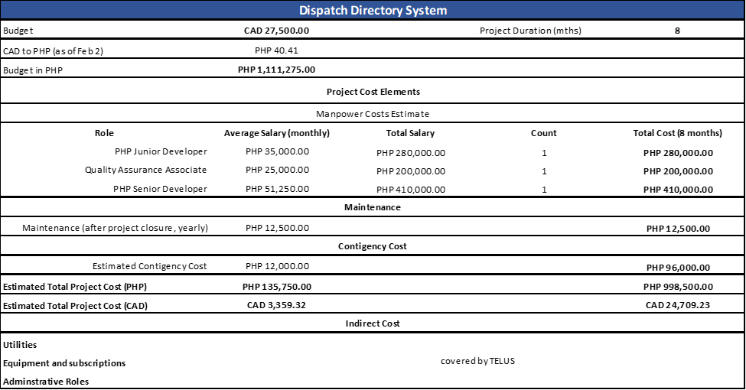

*Figure 2.4—1: Estimated Costs*

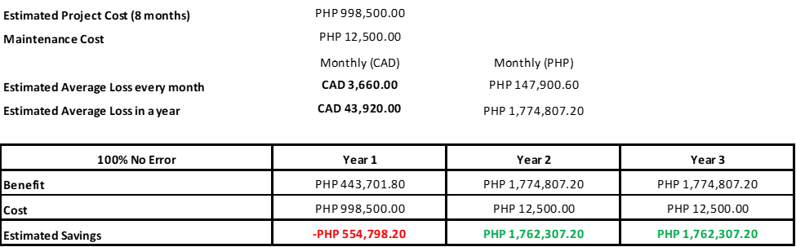 *Figure*

*2.4—2: Cost Benefit Analysis*

As shown on Figure 2, the budget allotted for the project is PHP 1,111,275.00 and the expected project duration spans 8 months. The following are the Project Elements:

* Manpower Costs Estimate
* Maintenance (after project closure)
* Contingency Cost

The estimated total monthly project cost PHP 135,750.00. If we are to breakdown the said total, 98% (*PHP 133,500.00*) of the estimate goes to the workforce while the rest goes to contingency fund. If the contingency fund for the said month is unused, it will rollover to the following month, and so forth. The accumulated unused contingency fund at the end of the project will be reduced from the total estimated cost of the project and will be considered as part of the estimated savings.

Another part of the estimate would be the maintenance cost after project closure, and it is crucial to ensure that the system is functioning optimally and effectively even after the project is completed.

In conclusion, the Dispatch Directory System project is expected to provide substantial benefits that outweigh the costs incurred. The project team should continuously monitor and evaluate the project to ensure that the benefits are being realized and that the project stays on track.

# 3. Project Charter

## 3.1. Project Purpose/Justification

#### 3.1.1. Business Need

The business need for this project is to improve the manual dispatch process of the Cable Repair Escalations Support Team (CREST) by developing a unified system that combines the functionality of the current three dispatch tools. Currently, the CREST team utilizes three separate tools for tracking and managing locations of TELUS facilities, assigning and tracking tasks and responsibilities within the organization, and notification of out-ofoffice schedules for TELUS managers. This manual process causes unnecessary delays, confusion, inaccuracy, and improper dispatch procedures, which can lead to unexpected costs due to invalid truck rolls or crew deployment.

By developing a single system that combines all the functionality of the current tools, the CREST team will have better navigation experience and be able to streamline their tracking and alert processes. This will improve the efficiency and effectiveness of the team, allowing them to focus on other important tasks such as responding to customer inquiries and completing their work more efficiently. The new system will also provide better visibility into the work of the CREST team, allowing TELUS managers to easily monitor the progress and identify potential issues within the organization.

The intended effect of this business case is to reduce costs by eliminating the need for multiple tools and preventing unexpected costs due to invalid truck rolls or crew deployment. It will also improve the efficiency and effectiveness of CREST, leading to improved outage restoration efforts and better customer service. Overall, the development of a unified dispatch system will help TELUS to better serve its customers and improve its bottom line.

#### 3.1.2. Business Objectives

As TELUS aims to continuously innovate and improve our services in order to meet the changing needs of our customers, the development of this system will help modernize and streamline the existing dispatch process, which will allow CREST team members to effectively track and manage their work while at the same efficiently respond to customers’ (technicians and managers) inquiries. By introducing innovative technologies and processes, the project will help the organization to stay ahead of the curve and remain competitive in an ever-changing market.

Also, TELUS aims to enhance the satisfaction and loyalty of our customers through exceptional service and support. The project, once developed, will help improve the accuracy and reliability of the dispatch process, will help minimize delays and confusion and ensure that technicians and managers are deployed correctly. By delivering a higher level of service and support, the project will contribute to the satisfaction and loyalty of customers.

## 3.2. Project Description

The Dispatch Directory System project aims to improve the efficiency and effectiveness of TELUS' Cable Repair Escalations Support Team (CREST) by developing a single, unified system that combines the functionality of the team's three current dispatch tools. The new system will provide a better user experience for CREST team members and help prevent unnecessary delays, confusion, inaccuracy, and improper dispatch procedures. It will also assist the company in providing better outage restoration efforts and avoiding unnecessary costs caused by invalid truck rolls and crew deployment.

The project will involve conducting an analysis of the existing CREST dispatch tools, designing a new system that combines these three tools, coding the various features and functionalities, integrating the tools, testing the system, and deploying it for use by the CREST team. Training will be provided to users and ongoing support will be offered as needed. The project is expected to be completed by **September 30, 2023**.

#### 3.2.1. Project Objectives

The project's main objective is to combine all three existing manual systems of CREST, namely COID (Central Office ID), Area of Responsibility Tracker, and OOO (Out-Of-Office) Alert System, into one system. Combining these three systems will help reduce the number of recorded invalid truck rolls and dispatch and at the same time lessen the time spent of an agent processing a request to less than the average of 9 minutes.

#### 3.2.2. Success Criteria

To achieve success on this project, the following objectives must be met within the designated time and budget allocations:

* The new system is adopted and used by the CREST team with at least a 90% satisfaction rate.
* Incorrect dispatch procedures are reduced by at least 50% in the first year of implementation.
* Outage restoration efforts are improved by at least 20% in the first year of implementation.
* The new system results in cost savings of more than a million pesos in the first year of implementation.
* The new system is completed and implemented within the budget and timeline established in the project plan.

#### 3.2.3. Requirements

This project must meet the following list of requirements to achieve success.

* The new dispatch system must have a user-friendly interface that is easy for CREST team members to navigate.
* The system must allow for the integration of all current dispatch tools, including the COID Tracking System, the Area of Responsibility Tracker, and the OOO Alert System.
* The system must have the ability to track and manage customer and technician schedules, as well as job assignments and tasks.

The system must be able to generate reports and analytics to help managers track the performance of their teams.

The system must be developed using PHP and SQL and must be compatible with the company's licensed Google Suite tools.

* The system can be deployed within TELUS’ VDI environment.
* The project must be completed within a specified timeframe and budget.

Additional requirements may be added as necessary, with project sponsor approval, as the project moves forward.

#### 3.2.4. Constraints

There are several constraints that the project manager must consider for this project:

* **People**: One of the main constraints is the availability of skilled personnel. The project team will need to be trained in the new dispatch system, and it may be challenging to find enough skilled developers to complete the project on time.

* **Money**: The budget is a significant constraint, as the project must be completed within the allocated funds. The project manager must ensure that all expenses are carefully planned and controlled to stay within budget.

#### 3.2.5. Assumptions

The following is a list of assumptions. Upon agreement and signature of this document, all parties acknowledge that these assumptions are true and correct:

* The system built is only accessible within the TELUS network.
* The developers who will work on this project are dedicated onshore developers thus the development tools and testing environment are readily available on their equipment provided by TELUS.
* TELUS has the environment to support the project development, implementation, and maintenance of the system.
* Indirect costs such as utilities (e.g., electricity, internet, office space) are already covered in the contract between TELUS and the client and will not be taken out of the project budget.

All legacy data can be extracted from the old tools and transitioned to the proposed project.

This project has the full support of the project sponsor, stakeholders, and all departments. Which means, any necessary approvals or permissions for the project will be obtained in a timely manner.

* The project timeline and budget will remain unchanged throughout the duration of the project.
* CREST will have the necessary skills and knowledge to adapt to the new system effectively as the Senior PHP Developer will only provide job-aides and documentation to the account’s SME during the transition/training phase.

#### 3.2.6. Preliminary Scope Statement

The scope of this project includes the development of a single system that combines the functionality of the three dispatch tools currently used by the Cable Repair Escalations Support Team (CREST). This system will include features such as a COID directory to identify the correct location of TELUS facilities, a viewing module to retrieve relevant information about a COID, and a schedule module to show the availability of TELUS managers. The system will also include improved tracking processes to enhance the efficiency and effectiveness of CREST. The project will be considered complete upon successful deployment of the system to the CREST team, as well as the completion of one payroll cycle using the new system.

High-level resource descriptions for this project include the use of PHP and SQL to create a web portal, and the data migration of information from the current tools to the new system using Excel and PHP. The project will also include training for CREST team members on how to use the new system, as well as ongoing support as needed.

## 3.3. Risks

There are several high-level risks that the project team has identified as applying to this project. The project manager will determine and employ the necessary risk mitigation/avoidance strategies as appropriate to minimize the likelihood of these risks:

* **Lack of resources:** There is a risk that the project may not have access to sufficient resources (e.g., personnel, budget, equipment) to complete the project as planned.
* **Scope creep:** There is a risk that the scope of the project may expand beyond its original boundaries, leading to delays and cost overruns.

**Dependencies on external parties:** The project may be dependent on the cooperation and performance of external parties, which could lead to delays or other issues.

**Changes in technology:** There is a risk that changes in technology or industry standards may impact on the project, requiring additional work or resources.

* **Security vulnerabilities:** There is a risk that the project may be vulnerable to security breaches or data loss, which could have serious consequences.
* **Human error:** There is a risk that mistakes, or errors made by project team members could impact the project.
* **Unforeseen circumstances:** There is a risk that unforeseen circumstances (e.g., natural disasters, market shifts) could impact the project in unexpected ways.

## 3.4. Project Key Deliverables

The following deliverables must be met upon the successful completion of the project. Any changes to these deliverables must be approved by the project sponsor.

* A consolidated dispatch system that combines the functionality of the three current dispatch tools (COID Tracking System, Area of Responsibility Tracker, and OOO Alert System).
* A single system for accessing all dispatch information, rather than having to navigate multiple separate tools.
* Enhanced accuracy and avoidance of incorrect dispatch procedures, such as invalid truck rolls or invalid technician and crew deployment. • Streamlined and improved dispatch processes or procedures.
* Improved outage restoration efforts and cost savings from avoiding unnecessary costs due to invalid truck rolls and crew deployment.
* Training materials for team members to effectively use the new system.
* A report detailing the benefits and cost savings achieved through the implementation of the consolidated dispatch system.

## 3.5. Summary Milestone Schedule

The project Summary Milestone Schedule is shown below and may be updated as requirements are further defined. Any changes will be communicated through project status meetings by the project manager.

|  |  |
| --- | --- |
| **Project Milestone** | **Target Completion Date** |
| Project kick-off meeting | February 1, 2023 |
| Analysis phase completion | February 28, 2023 |
| Design phase completion | March 31, 2023 |
| Implementation phase completion | May 31, 2023 |
| Testing and quality assurance phase completion | August 31, 2023 |
| Deployment phase completion | September 15, 2023 |
| Project close-out meeting | September 30, 2023 |

*Table 3.5—1: Summary Milestone Schedule*

## 3.6. Budget Summary

The image below shows a summary budget for the project, including the proposed cost category, description, and their estimated costs. This budget is necessary for the successful completion of the project.



*Figure 3.6—1: Budget Summary*

## 3.7. Project Approval Requirements

The successful completion of the project will be determined by the Project Sponsor, Mir Tolentino, based on the completion of all project deliverables and requirements as outlined in the project charter. Any deviations from the agreed upon requirements must be approved by the Project Sponsor before proceeding. Once all deliverables have been completed and all requirements have been met, the Project Sponsor will sign off on the project, indicating their approval and the successful completion of the project.

# 4. Project Management Approach

The Project Sponsor has full authority in terms of giving the go-signal to execute plans and any changes needed thereof. On the other hand, the Project Manager has the responsibility for managing and executing this project according to this Project Plan. The project team will consist of personnel from the administrative, product development, and quality assurance group.

The project manager will work with all resources to perform project planning. All project and subsidiary management plans will be reviewed and approved by the project sponsor. All funding decisions will also be made by the project sponsor. Any delegation of approval authority to the project manager should be done in writing and be signed by both the project sponsor and project manager.

# 5. Project Technical Approach

For the Dispatch Directory System project, our technical approach is based on a thorough analysis of the project requirements and constraints. Our team will follow a structured and agile product development methodology that is designed to ensure timely delivery of a highquality product that meets the client's expectations.

## 5.1. Product Development Methodology

Our product management approach is a hybrid of agile and traditional project management frameworks. We will utilize agile methods such as Scrum to allow for quick iterations and continuous feedback from stakeholders. At the same time, we will employ traditional project management methods such as Waterfall to ensure that the project is delivered on time and within budget.

The methodology includes the following steps:

* Project Initiation
* Planning
* Execution
* Monitoring and Controlling
* Closure

Throughout the product development life cycle, we will engage in continuous communication with the client to ensure that the project is on track and meets their needs. We will also prioritize user experience and design to ensure that the product is intuitive and user-friendly.

## 5.2. Technical Architecture

The Dispatch Directory System will be built using a modern, cloud-based technical architecture that is designed for scalability, security, and performance. Our team will utilize microservices architecture to allow for modular and flexible development.

The system will be hosted on a secure and reliable cloud platform, ensuring that it is accessible from anywhere in the world. We will also use best-in-class security measures to protect the system from cyber threats and unauthorized access.

The user interface will be built using modern front-end technologies such as React and

Angular, providing a responsive and intuitive experience for users. We will also leverage a variety of back-end technologies, including Node.js, Java, and Python, to provide a robust and reliable system. Our team will also use automated testing and continuous integration and deployment (CI/CD) processes to ensure that the system is always up-to-date and functioning optimally.

The technical architecture of the Dispatch Directory System project is designed to ensure that the application is efficient, reliable, and secure. The architecture is based on a client-server model, where the client is a web browser, and the server is the application server.

The server-side of the application will be developed using Java Enterprise Edition (JEE) and will run on an Apache Tomcat web server. The application will use a three-tier architecture, separating the presentation, application, and data layers.

The presentation layer will consist of HTML, CSS, and JavaScript, which will be used to create the user interface. The application layer will include Java Servlets and Java Server Pages (JSPs), which will handle the business logic of the application. The data layer will be based on a relational database management system (RDBMS), such as MySQL or Oracle, which will store and manage the application data.

To ensure the security of the application, the technical architecture will include a number of security measures. These will include user authentication and authorization, data encryption, secure data transmission, and secure coding practices.

In addition, the technical architecture will be designed to be scalable, so that it can accommodate future growth and expansion. This will be achieved using load balancers, clustering, and other scalability techniques. Overall, the technical architecture of the Dispatch Directory System project will ensure that the application is robust, secure, and scalable, and will provide a solid foundation for the successful delivery of the project.

# 6. Project Management Plans

## 6.1. Stakeholders Strategy Management Plan

#### 6.1.1. Introduction

The goal of the stakeholder management strategy for the project is to effectively engage and manage the expectations of all stakeholders throughout the project life cycle. This includes identifying and analyzing stakeholder needs and interests, developing a communication plan to keep stakeholders informed and engaged, and managing stakeholder expectations to ensure that the project delivers value and meets the needs of all stakeholders.

In addition, this stakeholder management plan for a Dispatch Directory System will ensure that the needs and expectations of all stakeholders are considered and balanced in the design and operation of the system. This includes ensuring that the system is effective and efficient in meeting the needs of its users, as well as being responsive to the concerns and feedback of stakeholders such as employees, customers, and community members.

The objectives of this strategy are to:

* Identify all key stakeholders and their level of interest in the project
* Analyze the needs and expectations of each stakeholder group
* Develop a communication plan to keep stakeholders informed and engaged throughout the project
* Identify and manage potential conflicts or competing objectives among stakeholders
* Ensure that the project delivers value and meets the needs of all stakeholders
* Establish a system for ongoing stakeholder engagement and feedback to monitor and evaluate the effectiveness of the stakeholder management plan and ensure that the project remains aligned with stakeholder needs and expectations.
* Involving the stakeholders in the planning and decision–making process to help ensure that the concerns of the stakeholders are all considered.

Some potential strategies for a Dispatch Directory System to have better stakeholder management could include:

* **Improving communication and transparency:** It can help improve communication between different stakeholders, such as dispatchers, drivers, and customers, by providing a centralized platform for information sharing. This can help reduce misunderstandings and improve trust between stakeholders.
* **Increasing efficiency:** Currently, it takes an average of 9 minutes for a tenured team member to process a dispatch request.The Dispatch Directory System can streamline processes and reduce the time and resources required to complete tasks, such as assigning and tracking deliveries. This can help improve the overall efficiency of the dispatch process and increase customer satisfaction.
* **Enhancing customer service**: A dispatch directory system can provide customers with real-time updates on the status of their orders and delivery, helping to improve the overall customer experience.
* **Reducing costs:** By automating and streamlining certain tasks, a dispatch directory system can help reduce the cost of operation and increase profitability.
* **Enhancing data analytics and decision-making:** The Dispatch Directory System can provide valuable data and insights that can help managers make better informed decisions about resource allocation, routes, and other key factors.

#### 6.1.2. Identify Stakeholders

The goal of the Stakeholder Management Strategy for the dispatch project is to ensure that all stakeholders are identified, their interests and influence on the project are understood, and their needs and expectations are effectively managed. In other words, the aim of the stakeholder management strategy for the dispatch directory system is to identify and engage with all individuals or groups that have a personal stake in the project and will be impacted by its implementation or success. To achieve this, the project team will follow a structured methodology to identify stakeholders. This will involve conducting interviews with key personnel, reviewing relevant documents and data sources, and engaging with various stakeholders through focus groups and other consultation processes.

To identify its stakeholders, a structured method can be used which involves:

* Identifying all potential stakeholders through a stakeholder analysis. This includes identifying internal stakeholders (such as employees and management) and external stakeholders (such as customers, suppliers, and regulatory bodies).
* Prioritizing stakeholders based on their level of influence, power, and impact on the project. This will help determine how much time and resources should be allocated towards engaging with each stakeholder.
* Developing a stakeholder engagement plan to outline how each stakeholder will be engaged and communicated with throughout the project.
* Maintaining ongoing communication with stakeholders to ensure that their needs and concerns are addressed and that the project stays on track.

Stakeholders will be defined as any individuals or groups who have an interest in or are impacted by the project, such as employees, customers (Technicians and Managers), Management team, and/or other organizational team members. The project team will use a stakeholder analysis tool to categorize stakeholders based on their level of interest and influence and will develop tailored communication and engagement plans for each stakeholder group. This will help to ensure that all stakeholders are kept informed about the project's progress and are able to provide input and feedback as needed. By effectively managing stakeholders, the project team can build support for the project, address any concerns or issues that may arise, and increase the chances of project success.

#### 6.1.3. Key Stakeholders

The key stakeholders in this dispatch directory system project are TELUS Technicians, TELUS Managers, and CREST (Cable Repair Escalations Support Team) Team Members. These individuals will be directly impacted by the project as they are the primary users of the system. As such, it is important to ensure that their needs and concerns are properly addressed during the development of the system.

In addition, the project sponsor and project manager have also been identified as key stakeholders as they will be responsible for ensuring the successful delivery of the project. It is essential to involve these stakeholders in the decision-making process and ensure that their input is taken into consideration throughout the project.

|  |  |  |  |  |
| --- | --- | --- | --- | --- |
| **Name** | **Position** | **Internal, External** | **Project Role** | **Contact Information** |
| Mir Tolentino | Manager of Operations | Internal | Project Sponsor | mir.tolentino@telusinternationa  l.com |
| CREST Team | Team  Members of  Operations | Internal | Internal User of the system | CREST@telus.com |
| TELUS Technicians | Technicians, Customers | External | External user of the system | Cablerepair@telus.com |
| TELUS Managers | Managers, Customers | External | External user of the system | cnoemanagers@telus.com |
| Roselyn Angeles | Consultant | External | Project  Manager | roselyn.angeles@telusinternatio nal.com |

*Table 6.1—1: Stakeholder Register/Profile*

#### 6.1.4. Stakeholder Analysis

Conducting a stakeholder analysis is a crucial element of the stakeholder management plan for the dispatch directory system. It involves identifying and evaluating all individuals or groups that have a vested interest in the project and will be impacted by its implementation or success. By conducting a stakeholder analysis, the project team can determine who the key stakeholders are, their level of influence and power, and their potential impact on the project. This information is crucial for developing an effective stakeholder management strategy, as it helps the project team to prioritize the stakeholders and determine how best to engage and communicate with them throughout the project. The table below outlines the stakeholders for the project, indicating those who have a high or low level of interest and power in the development process.

|  |  |  |  |
| --- | --- | --- | --- |
| **Name** | **Power/ Interest** | **Current**    **Engagement** | **Potential Management Strategies** |
| Mir Tolentino | High/High | Neutral | Mir is very approachable and likes to be informed / updated via email, video calls and in person. Manage closely and collaborate with her to keep her fully engaged with the project's progress. |
| CREST | Low/High | Supportive | Team Members of CREST are resilient and very productive. They are very much supportive of changes within their organization that could provide potential growth and success to their team. They need to be aware of the changes and to let them know that the change is in everyone's best interest. They can offer great insights and ideas for the project. |
| TELUS Technicians | Low/Low | Neutral | They are one of the customers of CREST Team and are assigned on field in Canada. Monitor them as they will most likely require some communication regarding the project's development. |
| TELUS Managers | High/Low | Leading | They manage TELUS field technicians in Canada, and they are one of the customers of CREST Team. They can be considered context-setters as they can have a lot of influence in the company and over the project but will not let themselves be involved in the project details. There's a need to keep them satisfied/ up to date with the project's progress but do not over-communicate with them as this might lead to a total loss of interest. |
| Roselyn Angeles | Low/High | Supportive | She is the project manager who oversees the progress of the project. She gets along with everybody in the project team and is professional. Keep her informed of the deliverables' completions and delays, issues, changes, and other projectrelated concerns. |

*Table 6.1—2: Stakeholder Analysis*

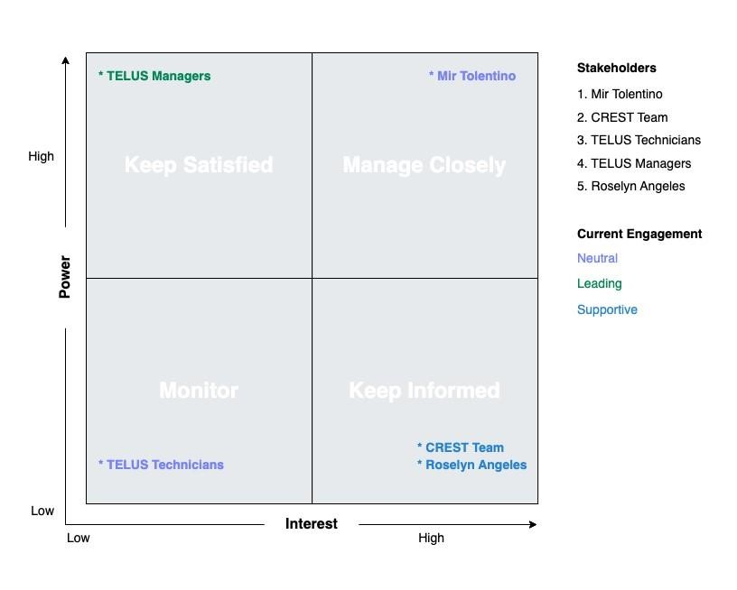

*Figure 6.1—1: Stakeholder Analysis*

## 6.2. Scope Management Plan

#### 6.2.1. Introduction

The scope management plan for the Dispatch Directory System outlines the best practices and cutting-edge tools that will be used to define, document, and control the scope of the project. By leveraging agile methodologies and real-time collaboration tools, the project team will be able to deliver an innovative dispatch directory system that meets the needs of all stakeholders.

**Scope Definition:** The scope of the Dispatch Directory System will be defined through the following activities:

1. **Requirements gathering:** The project team will use a variety of techniques to gather and document the requirements for the system, including users' interviews, focus group discussions, and online surveys.
2. **User stories:** The project team will create user stories to describe the functionality of the system from the perspective of the end user. These stories will be prioritized based on business value and will be used to guide the development process.

1. **Scope statement:** The scope statement will be created using the user stories and requirements as input. It will provide a high-level overview of the project scope, including the deliverables, exclusions, and constraints.

1. **Scope baseline:** The scope baseline will be created by incorporating the scope statement and the user stories into a project management plan. It will be regularly updated as the project progresses to reflect changes in scope.

**Scope Documentation:** The scope of the Dispatch Directory System will be documented in the following ways:

1. **Requirements documentation:** The requirements for the system will be documented in a requirements specification document.

1. **Project management plan:** The project management plan will include the scope statement, the scope baseline, and any other relevant information about the scope of the project.

1. **Change log:** A change log will be maintained to track all changes to the scope of the project, including the description of the change, the impact on the project, and the required approvals.

**Scope Control:** The scope of the Dispatch Directory System will be controlled through the following activities:

1. **Scope verification:** The project team will use agile testing techniques to verify that the deliverables of the project meet the requirements and align with the scope statement.

1. **Scope change control:** Any changes to the scope of the project will be managed through a formal change control process, which will include an assessment of the impact on the project schedule, budget, and quality.

1. **Scope change review:** A scope change review will be held for each change request to ensure that the change is necessary, feasible, and aligned with the project objectives.

#### 6.2.2. Scope Management Approach

1. Authority and responsibility for scope management will be held by the Project Manager, Roselyn Angeles, who will work closely with the project sponsor, Mir

Tolentino, and other key stakeholders to define and manage the scope of the project.

1. The scope of the project will be defined through the creation of a Scope Statement, Work Breakdown Structure (WBS), and WBS Dictionary, as well as a detailed Statement of Work (SOW). These documents will clearly outline the project deliverables, tasks, and requirements, and will be reviewed and approved by the project sponsor and other stakeholders before work begins.

1. The scope of the project will be measured and verified with quality checklists, work performance measurements, and regular review of the project's progress against the scope baseline. Any deviations from the scope baseline will be identified and addressed through the scope change process.

1. The scope change process for the Dispatch Directory System project will involve the submission of a scope change request by the Project Manager, with final approval being granted by the project sponsor. Any changes to the scope of the project must be carefully evaluated to ensure that they align with the project's goals and objectives, and do not negatively impact the project schedule or budget.

1. The final project deliverables will be accepted and approved by the project sponsor and other key stakeholders, with the Project Manager being responsible for ensuring that all project requirements have been met. The successful completion of the project will be confirmed once all deliverables have been accepted and any outstanding issues have been resolved.

#### 6.2.3. Roles and Responsibilities

The following roles and responsibilities have been assigned in relation to scope management:

* **Project manager:** The project manager is responsible for defining and documenting the scope of the project, as well as controlling and approving scope changes.
* **Product owner:** The product owner is responsible for representing the needs and priorities of the stakeholders, and for ensuring that the project delivers value to the business.
* **Project team:** The project team is responsible for verifying the scope of the project, and for raising change requests if necessary.
* **Stakeholders:** Stakeholders are responsible for providing input on the requirements and scope of the project, and for approving scope changes as needed.

#### 6.2.4. Scope Definition

The scope of this project includes the development of a single system that combines the functionality of the three dispatch tools currently used by the Cable Repair Escalations Support Team (CREST). This system will include features such as a COID directory to identify the correct location of TELUS facilities, a viewing module to retrieve relevant information about a COID, and a schedule module to show the availability of TELUS managers.

The system will also include improved tracking processes to enhance the efficiency and effectiveness of the CREST team.

#### 6.2.5. Project Scope Statement

The project scope statement for the dispatch directory system project will detail the project's deliverables and the work necessary to create these deliverables.

**Product Scope Description:**

The Dispatch directory system will be a web-based tool that allows dispatchers to plan and schedule technicians' activities, such as service calls, site visits, and other tasks. It will also allow dispatchers to track the progress and accomplishments of technicians, as well as monitor the performance of the teams and individuals they oversee.

This system will include features such as a calendar and task management tools, as well as reporting and analysis capabilities to help managers track their performance and the performance of their teams.

**Product Acceptance Criteria:**

The Dispatch Directory System will be considered complete and accepted by the customer when it meets the following criteria:

* All features and functionalities specified in the project scope statement have been developed and tested using the test cases created by the Quality Assurance Associate.
* The system has been successfully deployed within the TELUS’ VDI environment.
* The system has received positive feedback from users during UTA.
* The system has been thoroughly documented and user manuals have been created.

**Project Deliverables:**

The following list of deliverables will be provided upon successful completion of the project:

* Fully functioning Dispatch Directory System
* User manuals and training materials
* Technical documentation
* Any additional deliverables as specified in the Project Scope Statement and agreed upon by the Project Sponsor

**Project Exclusions:**

The following work is outside the scope of this project and will not be included:

* Integration of other systems or software not specifically mentioned in the project scope statement
* Customization or modification of the system beyond the scope specified in the project scope statement

**Project Constraints:**

The following constraints will impact the project:

* Limited budget
* Availability of resources such as workforce.

**Project Assumptions:**

The following assumptions have been made regarding this project:

* The system built is only accessible within the TELUS network.
* The developers who will work on this project are dedicated onshore developers thus the development tools and testing environment are readily available on their equipment provided by TELUS.
* TELUS has the environment to support the project development, implementation, and maintenance of the system.
* Indirect costs such as utilities (e.g., electricity, internet, office space) are already covered in the contract between TELUS and the client and will not be taken out of the project budget.
* All legacy data can be extracted from the old tools and transitioned to the proposed project.
* This project has the full support of the project sponsor, stakeholders, and all departments. Which means, any necessary approvals or permissions for the project will be obtained in a timely manner.
* The project timeline and budget will remain unchanged throughout the duration of the project.
* CREST will have the necessary skills and knowledge to adapt to the new system effectively as the Senior PHP Developer will only provide job-aides and documentation to the account’s SME during the transition/training phase.

#### 6.2.6. Work Breakdown Structure

The Work Breakdown Structure (WBS) is a hierarchical representation of the project scope that divides the project into smaller, more manageable components. Each level in the WBS represents a progressively more detailed view of the project, starting with the highest level and moving down to the lowest level. The WBS Dictionary is a companion document to the WBS that provides detailed information about each component in the WBS, including the scope of work, deliverables, responsibilities, and any other relevant information.

The project team will use the WBS and WBS Dictionary to divide the project scope into smaller, more manageable components and to assign responsibilities for each component. This will help to ensure that all aspects of the project are accounted for and that everyone on the team understands their role in delivering the project. The WBS and WBS Dictionary will also be used to track progress, identify and resolve issues, and ensure that the project stays on track and within scope. Overall, the WBS and WBS Dictionary are essential tools for managing the project scope and ensuring the project's success.

**Tasks**

**1.0 Project Management**

1.1 Project Initiation

1.1.1 Develop project charter

1.1.2 Identify stakeholders

1.1.3 Define project scope

1.2 Project Planning

1.2.1 Develop project schedule

1.2.2 Determine resources and budget

1.2.3 Create risk management plan

1.3 Project Execution

1.3.1 Assign tasks and responsibilities

1.3.2 Monitor and control project progress

1.4 Project Monitoring and Control

1.4.1 Monitor project deliverables

1.4.2 Control changes to project scope

1.5 Project Closeout

1.5.1 Obtain project sponsor approval

1.5.2 Complete final project report

**2.0 System Development**

2.1 Requirements Gathering

2.1.1 Conduct stakeholder interviews

2.1.2 Create requirements document

2.2 System Design

2.2.1 Develop system architecture

2.2.2 Create user interface design

2.3 Development

2.3.1 Write code for system functions

2.3.2 Test system functionality

2.4 Deployment

2.4.1 Install system on server

2.4.2 Conduct user acceptance testing

2.5 Maintenance and Support

2.5.1 Provide ongoing system support

2.5.2 Address system issues and bugs

**3.0 User Training**

3.1 Create Training Materials

3.1.1 Develop user manual

3.1.2 Create video tutorials

#### 6.2.7. Scope Verification

To ensure that the deliverables from the Dispatch Directory System project meet the original scope, the project team will utilize a variety of methods for scope verification. These methods may include:

* **Quality checklists:** These lists will outline the specific requirements that each deliverable is met in order to be accepted. The project team will use these checklists to verify that each deliverable meets all necessary criteria before moving forward.
* **Work performance measurements:** The project team will track and measure the progress of each deliverable as it is being developed. This will allow the team to identify any potential issues or deviations from the original scope and address them in a timely manner.
* **Scope baseline:** The project team will maintain a scope baseline, which is a snapshot of the original project scope. Any changes to the scope must be documented and approved before they are implemented. The scope baseline will be used to ensure that the final deliverables meet the original scope.
* **Formal acceptance:** The project sponsor, customer, and other stakeholders will formally accept each delivery as it is completed. This ensures that the project team is meeting the expectations of all relevant parties — allowing any necessary feedback or changes to be made in a timely manner.

Overall, it is important that the project team maintains consistent communication and collaboration with the customer and other stakeholders throughout the project in order to ensure that the deliverables meet the original scope and are formally accepted.

#### 6.2.8. Scope Control

The scope control process for the project will involve regular reviews of the project's deliverables and progress to ensure that they align with the original project scope as defined in the Project Scope Statement. Any deviations from the scope will be evaluated and, if necessary, changes to the scope will be documented and approved through the established scope change process. The Project Manager will be responsible for monitoring and controlling the project's scope, with assistance from the project team and stakeholders. Periodic reviews of the project's scope will be conducted to ensure that the project remains on track and within the defined boundaries. The project manager will also be responsible for ensuring that any scope changes are properly documented and that all impacted parties are notified of any changes.

The scope control process for the Dispatch Directory System project will involve the following steps for making changes to the scope baseline:

* A scope change request will be initiated by any stakeholder or team member who identifies a need for a change to the scope.
* The scope change request will be reviewed by the Project manager and the Project Sponsor to assess the impact of the change on the project schedule, budget, and resources.
* If the change is deemed low impact, the Project Manager can approve or deny the request. If the change is deemed high impact, the Project manager can approve

or deny the request. Any low impact change request approved or denied by the Project Manager can be reviewed and overruled by the Project Sponsor.

* If the request is approved, the Project Manager will create an action plan to proceed with the change and update the scope baseline and notify all relevant stakeholders of the change.
* If the request is rejected, the project team will continue with the original scope.

It is important to have a formalized process for making changes to the scope baseline in order to ensure that the project stays on track and within budget. Any changes to the scope should be carefully assessed and approved in order to avoid scope creeps and keep the project on track.

## 6.3. Cost Management Plan

The Cost Management Plan for the Dispatch Directory System project is designed to ensure that all costs associated with the project are effectively managed throughout its lifecycle. The plan outlines the format and standards by which the project costs will be measured, reported, and controlled.

**Cost management responsibilities:**

* The Project Manager will be responsible for overall cost management of the project and will be the primary point of contact for all cost-related issues.
* The Finance Team will be responsible for monitoring project costs and ensuring that they are within the approved budget.

**Cost change approval:**

* All cost changes must be approved by the Project Manager before they are implemented.
* If the cost change exceeds 10% of the total project budget, it must be approved by the Project Sponsor before it can be implemented.

**Cost measurement and reporting:**

* Costs will be measured and reported on a monthly basis, using a cost performance index (CPI) and a schedule performance index (SPI)
* Reports will be presented to the Project Sponsor on a monthly basis.

**Budget format and standards:**

* The budget will be presented in a clear and concise format, using a spreadsheet format such as Excel.
* The budget will be broken down into individual line items, with detailed cost estimates for each item.
* The budget will be updated on a monthly basis, with any changes clearly highlighted.

Overall, the Cost Management Plan for the Dispatch Directory System project is designed to ensure that all costs associated with the project are effectively managed and controlled, so that the project can be completed within the approved budget. This will help ensure that the project is completed successfully and on time.

#### 6.3.1. Cost Management Approach

The cost management approach for the dispatch directory system project will be based on the following principles:

* **Clear definition of costs**: The project team will work closely with stakeholders to clearly define and document the costs associated with the project, including labor, materials, equipment, and other expenses.
* **Budget development and tracking:** A detailed project budget will be developed and regularly updated throughout the project, with costs tracked and reported in real time.
* **Cost estimates:** The project team will use a variety of cost estimation techniques to ensure that the project budget is accurate and realistic.
* **Cost variance analysis:** The project team will closely monitor costs throughout the project and perform variance analysis to identify and address any cost overruns or savings.
* **Cost management roles and responsibilities:** Clear roles and responsibilities for cost management will be defined and communicated to all project team members.
* **Approval process for changes:** A formal process for approving changes to the project or its budget will be established and implemented.
* **Reporting and communication:** Regular cost reports will be prepared and shared with stakeholders, including the project sponsor, project team, and management.

By following these principles and practices, the project team will be able to effectively manage costs and ensure that the project stays on budget.

#### 6.3.2. Measuring Project Costs

The Cost Management Plan for the Dispatch Directory System project will include a detailed approach for measuring project costs using Earned Value Management (EVM). This will involve capturing and reporting on various Earned Value metrics, such as:

1. Budgeted Cost of Work Scheduled (BCWS) or Planned Value (PV) - This measures the budgeted costs of the work that was planned to be completed at a specific point in time.

**Example**:

To calculate the BCWS or Planned Value, we need to multiply the total labor cost of the TESTING WBS by its percentage of completion:

BCWS = Total labor cost of TESTING WBS x Percentage of completion

= (PHP 300,000) x 33.71%

= PHP 101,130

Therefore, the Budgeted Cost of Work Scheduled (BCWS) or Planned Value (PV) for the TESTING WBS is **PHP 101,130.**

1. Budgeted Cost of Work Performed (BCWP) or Earned Value (EV) - This measures the budgeted costs of the work that has been completed at a specific point in time.

**Example**:

To calculate the Budgeted Cost of Work Performed (BCWP) or Earned Value (EV), we need to know the percentage of work completed for each task or WBS element. Assuming that the percentage of completion for each of the Testing Phase tasks are as follows:

Week 26: Testing Phase 1 - 100%

Week 27: Testing Phase 2 - 75%

Week 28: Testing Phase 3 - 50%

Week 29: Testing Phase 4 - 25%

Then, we can calculate the Budgeted Cost of Work Performed (BCWP) or Earned Value (EV) as follows:

EV = BCWS x % of work completed

EV = (₱300,000 x 33.71%) + (₱75,000 x 8.43% x 0.75) + (₱75,000 x 8.43% x

0.50) + (₱75,000 x 8.43% x 0.25)

EV = ₱101,130 + ₱4,732.50 + ₱3,155 + ₱1,577.50 EV = ₱110,595

Therefore, the Budgeted Cost of Work Performed (BCWP) or Earned Value (EV) is **₱110,595.**

3. Actual Cost of Work Performed (ACWP) or Actual Cost (AC) - This measures the actual costs incurred for the work that has been completed at a specific point in time.

**Example**:

Assuming that the Actual Cost for the TESTING WBS is PHP 120,000, then:

AC = PHP 120,000

Therefore, the Actual Cost of Work Performed (ACWP) or Actual Cost (AC) is **PHP 120,000.**

These metrics will be used to perform cost variance analysis (CV), schedule performance index (SPI), and cost performance index (CPI) to measure the project's cost performance over time.

To assist in capturing these metrics, the project team will use project management software that is capable of tracking and reporting on EVM metrics. This software will also be used to forecast future project costs, and to review cost performance over time, across work packages or schedule activities.

1. Cost Variance (CV) measures the difference between the actual cost and the planned cost of the project. It is calculated by subtracting the actual cost from the planned cost. A negative CV indicates that the project is over budget, while a positive CV indicates that the project is under budget.

**Example**:

To compute the Cost Variance (CV), we need to subtract the Actual Cost of Work Performed (ACWP) or Actual Cost (AC) from the Budgeted Cost of Work Performed (BCWP) or Earned Value (EV).

From the previous example, the BCWP or EV is ₱110,595, and the ACWP or AC is ₱120,000.

CV = EV - AC

CV = ₱110,595 - ₱120,000

CV = -₱9,405

**Therefore, the Cost Variance (CV) for the Testing WBS is -₱9,405. A negative CV means that the project is over budget.**

1. The Schedule Performance Index (SPI) measures the project's schedule performance by comparing the planned schedule to the actual schedule. This index is calculated as the ratio of the BCWP to the BCWS. It is calculated by dividing the earned value by the planned value. A value of 1 indicates that the project is on schedule, while a value less than 1 indicates that the project is behind schedule, and a value greater than 1 indicates that the project is ahead of schedule.

**Example**:

From the previous computations, we have:

Earned Value (EV) = ₱110,595

Planned Value (PV) = ₱101,130

Plugging these values into the formula, we get:

SPI = EV / PV

SPI = ₱110,595 / ₱101,130

SPI = 1.093

Therefore, the **Schedule Performance Index (SPI) is 1.093. This indicates that the project is ahead of schedule, as the SPI is greater than 1.**

1. The Cost Performance Index (CPI) measures the project's cost performance by comparing the actual cost to the planned cost. This index is calculated as the ratio of the BCWP to the ACWP. It is calculated by dividing the value earned by the actual cost. A value of 1 indicates that the project is on budget, while a value less than 1 indicates that the project is over budget, and a value greater than 1 indicates that the project is under budget.

Example:

To calculate the Cost Performance Index (CPI), we need to use the following formula:

CPI = EV / AC where:

EV = Earned Value (BCWP)

AC = Actual Cost (ACWP)

From the previous computations, we have:

EV = ₱110,595

AC = ₱120,000

CPI = EV / AC

CPI = ₱110,595 / ₱120,000

CPI = 0.9216

Therefore, the **Cost Performance Index (CPI) is 0.9216.** This means that for every one peso spent, the project has earned only 0.92 pesos of value. **This indicates that the project is behind budget and may need to take corrective actions to bring the costs in line with the planned budget.**

In summary, the Cost Management Plan will ensure that the project costs are effectively managed and controlled throughout the project’s lifecycle by using Earned Value Management metrics, schedule performance index, and cost performance index. These metrics will help the team to identify the areas where the project is underperforming and take corrective actions to bring the project back on track.

6.3.3. Reporting Format

The ideal reporting format for the cost management plan of the Dispatch Directory system project would likely be a detailed spreadsheet or table. This format should include all relevant cost information such as project budget, actual costs incurred, projected costs, and any variances or discrepancies.

Additionally, the format should be easily understandable and accessible to all stakeholders, including the project team, stakeholders, and management. A bar chart or Gantt chart can also be included to provide a visual representation of the cost information.

The reporting format for the cost management plan of the Dispatch Directory system project would include the following elements:

1. **Executive Summary:** A brief overview of the cost management plan, including the project's overall budget, any major cost variances or issues, and any actions taken to address them.
2. **Budget Overview:** A detailed breakdown of the project's budget, including the total project cost, the cost of each phase or deliverable, and the costs associated with each project resource (e.g., labor, materials, equipment, etc.).
3. **Cost Variance Analysis:** A detailed analysis of any variances between the project's actual costs and the budgeted costs. This should include a detailed explanation of the causes of the variances, the impact on the project, and any actions taken to address them.
4. **Budget Forecast:** A projection of the project's future costs, including any potential cost variances and their potential impact on the project.
5. **Cost Management Metrics:** A set of key performance indicators (KPIs) that provide a snapshot of the project's cost performance, including cost variance, cost performance index (CPI), and schedule performance index (SPI).
6. **Approval and Sign-off:** A section for the project manager and other key stakeholders to review, approve, and sign off on the cost management plan.
7. **Appendices:** Any additional documentation or supporting materials, such as detailed cost breakdowns, invoices, or change request forms.

It is important to note that this is a general outline, and the reporting format may vary depending on the specific needs of the project and organization. However, it should provide a comprehensive overview of the project's cost management and performance in order to make informed decisions.

6.3.4. Cost Variance Response Process

The Cost Variance Response process for the dispatch directory system project will be as follows:

1. Control Thresholds:
   * The project will have several control thresholds set for cost variance.
   * These thresholds will be set at 5%, 10%, and 15% of the total project budget.
   * If the project triggers any of these thresholds, it will be considered a cost variance.

1. Identification of Variance:
   * The Project Manager will be responsible for identifying any cost variances and reporting them to the Project Sponsor.
   * The Project Manager will use the Earned Value Metrics and other cost management tools to identify and track any variances.

1. Analysis of Variance:
   * The Project Manager will analyze the variance to determine the root cause of the problem and develop options for corrective action.
   * The Project Manager will also consider the impact of the variance on the project schedule and scope.

1. Presentation of Options:
   * The Project Manager will present the options for corrective action to the Project Sponsor.
   * The options will be based on the root cause of the variance and the impact on the project schedule and scope.

1. Approval of Corrective Action:
   * The Project Sponsor will review the options and approve an appropriate action to bring the project back on budget.
   * This may include increasing the budget, reducing scope or quality, or implementing other corrective actions.

* + Implementation of Corrective Action:
  + The Project Manager will implement the approved corrective action and monitor the results.
  + The Project Manager will also update the project schedule and budget accordingly.

7. Reporting:

* The Project Manager will report the cost variance, corrective action taken, and the results of the corrective action in the Monthly Project Status Report.
* The Project Manager will also provide updates on the project budget and schedule.

The Cost Variance Response process will be an ongoing process throughout the project lifecycle. The Project Manager will be responsible for monitoring and controlling the project costs, and the Project Sponsor will be responsible for approving any corrective actions as needed.

6.3.5. Cost Change Control Process

The cost change control process will include the following steps:

* **Identification of the cost change:** Any proposed changes to the project budget or costs must be identified and documented on a cost change request form.
* **Analysis of the cost change:** The proposed change will be analyzed by the project team to determine the potential impact on the project schedule, resources, and overall budget.
* **Approval of the cost change:** The cost change request will be reviewed and approved by the project sponsor and other relevant stakeholders.
* **Implementation of the cost change:** Once approved, the cost change will be implemented in accordance with the project schedule and budget.
* **Tracking and monitoring of the cost change:** The project team will track and monitor the impact of the cost change on the project schedule and budget, and any necessary adjustments will be made to ensure the project stays on track.
* **Reporting on the cost change:** The cost change will be reported in the monthly project status report, along with any relevant financial information and any corrective actions taken.

The cost change control process will be implemented to ensure that any changes to the project budget or costs are identified, analyzed, and approved in a timely manner. This will help to minimize the impact of cost changes on the project schedule and budget and help to ensure that the project stays on track to meet its objectives.

6.3.6. Project Budget

Budgeting is a crucial component of project management that involves planning, estimating, and controlling project costs. For the Dispatch Directory System project, a budget has been developed to ensure that project costs are identified, monitored, and controlled throughout the project's life cycle.

The budget includes direct and indirect costs, and it is designed to provide the project team and stakeholders with a comprehensive understanding of the financial resources required to successfully complete the project. This budget will serve as a baseline for monitoring the project's financial performance and ensuring that it remains on track to meet its goals and objectives within the approved budget.

Approved Budget: CAD 27,500.00 (PHP 1,111,275.00)

Direct Costs:

* Maintenance Cost: PHP 12,500.00 (Yearly after project closure)
* Manpower Cost: PHP 890,000.00 (for 8 months)
* Contingency Cost: PHP 96,000.00 (for 8 months)
* Total Project Cost: PHP 998,500.00 (for 8 months)

Indirect Costs:

* Utilities
* Equipment and Subscriptions
* Administrative Roles

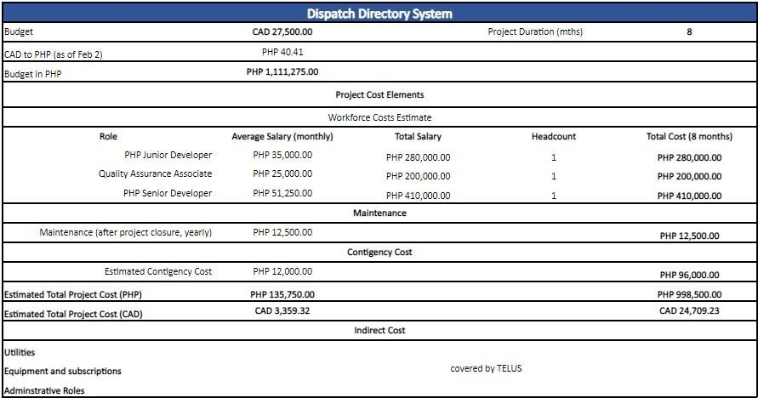

*Figure 6.3—1: Summary of Budget*

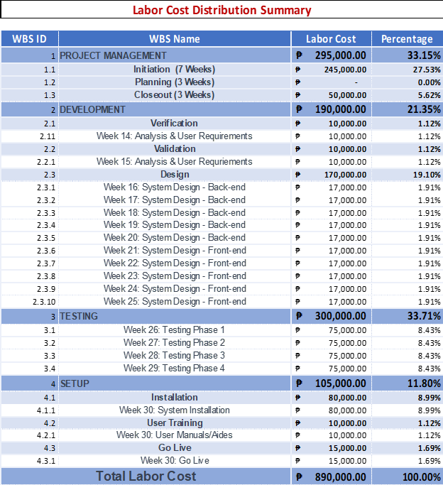

*Figure 6.3—2: Summary of Labor Cost Distribution*

*Image 6.3.6.2: Labor Cost Distribution Summary*

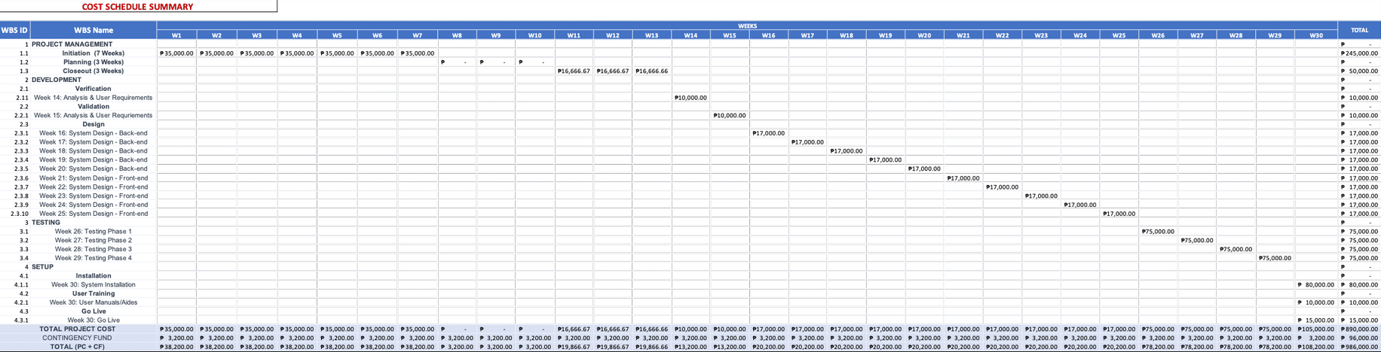

*Figure 6.3—3: Summary of Cost Schedule*

*Image 6.3.6.3: Cost Schedule Summary*

49

## 6.4. Schedule Management Plan

6.4.1. Introduction

The schedule management plan is a crucial component of the Dispatch Directory System project as it outlines the approach and methodology for effectively managing the project timeline and ensuring that the project is completed within the established timeframe. This plan includes the schedule management approach, schedule control, schedule changes and thresholds, and scope change.

1. The schedule management approach outlines the overall strategy and methodology for managing the project schedule.
2. The schedule control provides the processes and procedures for monitoring and controlling the project schedule.
3. The schedule changes and thresholds outline the procedures and processes for managing changes to the project schedule.
4. The scope change outlines the process for managing changes to the project scope.

By creating a detailed and comprehensive schedule management plan, the project team will be able to stay on top of the project schedule, manage and mitigate risks, and communicate effectively with stakeholders and management. This will help to ensure that the project is completed on time, within budget and to the satisfaction of all stakeholders.

6.4.2. Schedule Management Approach

The schedule management plan is a critical component of the Dispatch Directory System project. It is designed to provide a framework for the development and management of the project schedule. The schedule management approach outlined in this document will ensure that the project is completed on time and within budget by providing a clear and comprehensive plan for the project schedule, milestones, and roles and responsibilities.

The schedule management approach for the Dispatch Directory System project will be based on the following principles:

1. **Scheduling Tool/Format:** The project schedule will be created and managed using Google Sheet. This will allow for the creation of a detailed project schedule that includes all tasks, dependencies, and resources required for the successful completion of the project, as well as the ability to share and collaborate with project team members. The Project manager will also provide a Gantt chart for a much more detailed schedule for the project, this will be created using Microsoft Excel.

1. **Schedule Milestones:** The project schedule will be broken down into key milestones that will serve as markers for progress and success. These milestones will be used to track progress, identify potential issues, and will adjust as needed.

The schedule will include the following milestones:

* **Analysis Phase:** The analysis phase of the project will be completed, including the gathering of data needed for the project’s completion and gathering tools that will be needed for the project and identification of areas where improvements can be made.
* **Design Phase:** The design phase of the project will be completed, including the design of the user interface, the determination of the functionalities and features of the system, and the development of a plan for integrating the three tools into a single platform.
* **Implementation Phase:** The implementation phase of the project will be completed, including the coding of various features and functionalities, the integration of the three tools, and the testing of the system to ensure that it is working as intended.
* **Deployment Phase:** The deployment phase of the project will be completed, including the training of users on how to use the system and the provision of ongoing support as needed.
* **System Go-Live:** The dispatch system will be fully operational and available for use by the CREST team.
* **System Review:** A review of the system will be conducted to assess its performance and identify any areas for improvement.
* **Project Close:** The project will be formally closed, and a final report will be prepared documenting the results and outcomes of the project.

**c. Schedule Development Roles and Responsibilities:** The project schedule will be developed and managed by the project manager, in collaboration with the project team. The project manager will be responsible for creating the schedule, updating it as needed, and reporting on progress to stakeholders. The project team members will be responsible for providing input and assistance with the schedule, as well as for meeting their individual task deadlines.

Specific roles and responsibilities for schedule development will include:

* + - * **Project Manager:** Responsible for overall schedule development and management, including creating and updating the project schedule, identifying, and managing schedule risks, and ensuring that the schedule aligns with project objectives.

* + - * **Team Members:** Responsible for providing input and support to the project manager during the schedule development process, including identifying and communicating task dependencies, providing task estimates, and updating task status.

* + - * **Team Leader:** Responsible for providing input and support to the project manager during the schedule development process, including identifying and communicating task dependencies, providing task estimates, and updating task status.

Regular schedule reviews will be conducted to ensure that the project remains on track and that any issues or delays are identified and addressed in a timely manner. The project team will also establish schedule thresholds and change control processes to ensure that any changes to the schedule are managed in a controlled and effective manner.

6.4.3. Schedule Control

The schedule control plan for the dispatch directory system project outlines the procedures and processes that will be used to manage and control the project schedule throughout the life of the project. This includes the following key elements:

• Schedule Updates:

▪ The project schedule will be updated on a regular basis, typically on a weekly or bi-weekly basis, to reflect any changes or progress made on the project.

• Schedule Reviews:

The project schedule will be reviewed by the project team and stakeholders on a regular basis, typically monthly, to ensure that it is accurate and up to date.

This will include reviewing the schedule for completeness, identifying any potential issues or risks, and making any necessary adjustments.

• Communicating the schedule and progress:

The project schedule and progress will be communicated to all stakeholders, including the project team, stakeholders, and management, on a regular basis.

This will be done through regular project status reports, schedule status reports, and other forms of communication as appropriate.

• Roles and responsibilities:

* + - The project manager will be responsible for overall schedule control, including updating and reviewing the schedule, communicating schedule and progress, and making any necessary adjustments to the schedule as needed.
    - The project team members will be responsible for providing accurate and timely information and progress updates to the project manager, which will be used to update the schedule.
    - Stakeholders will be responsible for reviewing the schedule and providing feedback, as well as communicating any schedule changes or requirements that may impact the project.
    - This schedule control plan will be implemented throughout the life of the project, to ensure that the project schedule is accurate, up-to-date, and reflective of the current project status always. This will help to ensure that the project stays on track, that stakeholders are kept informed of progress, and that any potential issues or risks are identified and addressed in a timely manner.

6.4.4. Schedule Changes and Thresholds

The Schedule Changes and Thresholds section of the Schedule Management Plan will outline the procedures for handling schedule changes throughout the project. This includes the boundary conditions set by the project sponsor, which establish the parameters within which the project schedule must operate.

A change threshold of 10% will be used as a guideline for determining when a schedule change request is necessary. This means that any proposed change to the project schedule that exceeds a 10% deviation from the original schedule must be reviewed and approved by the sponsor before it can be implemented. Additionally, it allows the sponsor to consider the potential impact of any schedule changes on the project's budget, resources, and timelines before they are approved.

The boundary conditions that the project sponsor can set to establish the schedule parameters may include:

* + **Project completion date:** The sponsor may set a specific date by which the project must be completed. Any proposed schedule change that would result in the project not being completed by this date must be reviewed and approved by the sponsor.
  + **Milestone completion dates:** The sponsor may set specific dates for certain project milestones to be completed. Any proposed schedule change that would result in a milestone not being completed on the specified date must be reviewed and approved by the sponsor.
  + **Resource constraints:** The sponsor may set limits on the resources available for the project. Any proposed schedule change that would result in exceeding these resource constraints must be reviewed and approved by the sponsor.
  + **Budget constraints:** The sponsor may set a specific budget for the project. Any proposed schedule change that would result in exceeding this budget must be reviewed and approved by the sponsor.

For example, if the original project schedule estimated a task to take 20 days to complete, and a proposed change would increase that task's duration to more than 22 days, a schedule change request would be necessary, and the sponsor would need to review and approve the change before it can be implemented.

Another example, the project sponsor has set a completion date of December 31, 2023, for the Dispatch Directory System project. The project schedule has been set to complete all the activities by this date. However, due to unforeseen issues, a proposed schedule change must be made to push the completion date to January 15, 2024. This change exceeds the 10% change threshold, so it must be reviewed and approved by the sponsor before it can be implemented.

6.4.5. Scope Change

The scope change process will be implemented to ensure that any new deliverables or requirements that were not previously considered as part of the original schedule’s development are properly managed and integrated into the project.

The process will include the following steps:

**1. Identification of the scope change**

a. The project team will identify any new deliverables or requirements that need to be added to the project.

**2. Impact assessment**

* + - * 1. The project team will assess the impact of the scope change on the project schedule and resources.
        2. This will include an evaluation of the additional time and resources required to complete the new deliverables or requirements, as well as any potential delays to the project schedule.

**3. Schedule and resource analysis**

a. The project team will analyze the current status of the project schedule and resources to determine how the scope change will affect the project moving forward.

**4. Approval process**

* + - 1. The scope change will be reviewed and approved by the project sponsor and key stakeholders.
      2. The project sponsor will make the final decision on whether or not to proceed with the scope change.

**5. Implementation**

a. Once the scope change is approved, the project team will integrate the new deliverables or requirements into the project schedule and resources.

**6. Monitoring and control:**

a. The project team will monitor the progress of the scope change and make any necessary adjustments to the project schedule and resources to ensure that the project remains on track.

**7. Closeout:**

a. The scope change will be closed out once all new deliverables or requirements have been completed and the project schedule and resources have been updated accordingly.

It is important to note that scope changes can have a significant impact on the project schedule and resources and must be managed carefully to ensure that the project stays on track and within budget.

## 6.5. Staffing Management Plan

6.5.1. Introduction

A strong human resource management strategy is critical to the success of any project. It acts as a template for how the project team will be managed and structured, and it assists in ensuring that the appropriate people with the right qualifications are in the right place at the right time. Roles and duties, communication protocols, and performance management measures are all part of the strategy.

Using this plan, the project manager and project team can effectively manage the project by ensuring that all team members understand their roles and responsibilities, that communication is open and effective, and that performance is monitored and managed in a way that contributes to the project's overall success.

6.5.2. Roles and Responsibilities

An effective human resources management plan is crucial for the successful completion of any project. It outlines the roles and responsibilities of all project team members and stakeholders, ensuring that everyone is aware of their individual contributions and how they fit into the bigger picture.

The plan also defines the level of authority and decision-making power held by each team member, ensuring that resources are allocated and utilized effectively. By clearly defining competencies and skill requirements, the plan ensures that the right people are in the right roles to achieve project success.

Overall, the human resources management plan acts as a roadmap for the project team, guiding them towards successful project execution and delivery.

|  |  |  |  |
| --- | --- | --- | --- |
| **Role** | **Authority** | **Responsibility** | **Competency** |
| Project Sponsor | Approves the project's business case and budget. Provides strategic direction & resources. | Ensures that the project is aligned with the organization's strategic goals and objectives, and that it delivers the expected benefits and value. Provide high-level oversight | Strong leadership and  strategic thinking  skills  Ability to  communicate  effectively with a |

|  |  |  |  |
| --- | --- | --- | --- |
|  | Helps to secure stakeholder buyin. Resolves major issues and conflicts. Can allocate project resources and approve changes to project scope, schedule, and budget that has high impact. | and guidance to the project manager.  Secure resources and support from key stakeholders. Help to communicate project progress and benefits to the organization. | wide range of stakeholders. Deep understanding of the organization's mission, goals, and values.  Ability to secure resources and support for the project. |
| Project  Manager | Full decisionmaking authority on the project. Can allocate project resources and approve changes to project scope, schedule, and budget that has low impact. | Oversee the entire project, including project planning, execution, monitoring, control, and closeout.  Ensure project objectives are met on time, within budget, and to the required quality standards. | Strong leadership, communication, and project management skills.  Experience in managing complex projects. |

|  |  |  |  |
| --- | --- | --- | --- |
| Internal  User of the  System  (CREST Team) | Utilizes the system as designed to complete work activities.  Provides feedback on system usability, functionality, and performance. | Complete work activities using the system as designed. Ensure data accuracy and completeness.  Report system issues and problems to the project team. Provide feedback on system usability, functionality, and performance. | Understanding of the work processes and activities for which the system is being used.  Knowledge of the data and information required to complete assigned work activities.  Basic computer skills, including proficiency in the use of the system. |
| External  Users of the  System  (TELUS  Technicians) | Accesses and uses the system to receive and respond to service  requests.  Updates service request statuses. | Review and respond to service requests in a timely manner. Maintain accurate and uptodate information on service request statuses.  Communicate with internal stakeholders as needed to | Knowledge of the tools, equipment, and methods required to complete service requests.  Ability to diagnose and troubleshoot |
|  | closes out completed service requests. | complete service requests. Close out completed service requests. | technical issues. Understanding of the importance of maintaining accurate and up-to-date information in the system. |
| External  Users of the  System  (TELUS  Managers) | Accesses and uses the system to review, approve, or reject service requests. Assigns service requests to internal or external technicians. Monitors and reports on service request status and completion. | Review service requests and approve or reject based on organizational policies and priorities.  Assign service requests to internal or external technicians  based on skill and availability. Monitor and report on service request status and completion to internal stakeholders and customers. | Knowledge of the organization's policies and priorities related to service requests.  Ability to assign and prioritize work  assignments based on technician skill and availability.  Understanding of the importance of accurate and timely reporting on service request status and completion. |

*Table 6.5—1: Staffing Management Roles and Responsibilities*

6.5.3. Project Organizational Charts

Project organizational chart of the Dispatch Directory System provides a visual representation of the project team and the relationships between the key stakeholders. The project sponsor is typically at the top of the chart, followed by the project manager who is responsible for managing the project's resources, scope, and schedule. An internal user of the system, such as the CREST Team, may also be included to provide input on the system requirements and participate in user testing. Two external users of the system (TELUS Technicians, and TELUS Managers) may also be included to provide feedback on the system's usability and functionality. The organizational chart helps to clarify the roles and responsibilities of each stakeholder, ensuring that everyone is aligned with the project's goals and objectives.

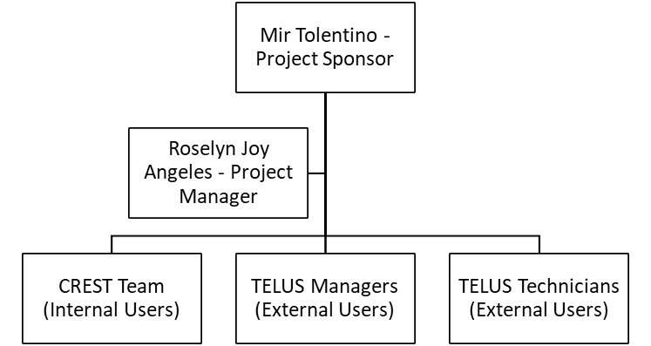

*Figure 6.5—1: Project Organizational Chart*

6.5.4. Staffing Management

The Staffing Management Plan for the Dispatch Directory System project is a critical component in ensuring the successful execution of the project. It outlines the strategies and processes for acquiring, managing, and releasing human resources throughout the project lifecycle.

* Acquisition of human resources will be done in a timely manner to ensure that the necessary skills and expertise are in place when needed. This may include recruiting new hires, hiring contractors, or utilizing internal staff. The timeline for resource acquisition will be aligned with the project schedule to ensure that resources are available when needed.
* Training for any resources with identified gaps in skills required will be provided to ensure that they have the necessary knowledge and capabilities to perform their roles effectively. This may include both on-the-job training and formal training programs.
* Performance reviews will be conducted regularly to assess the performance of team members and identify areas for improvement. These reviews will also provide feedback on how well team members are meeting the project's expectations and objectives.
* A rewards and recognition system will be implemented to acknowledge and motivate outstanding performance. This may include bonuses, promotions, and other incentives.

It is important to note that depending on the scope of the project, there may be other items included in staffing management such as government and/or regulatory compliance, organizational health, and safety, etc. It depends on the specific requirements and regulations of the industry and the location in which the Dispatch Directory System project is being implemented. Government and regulatory compliance may be a consideration if the project is subject to specific laws and regulations related to data privacy and security. Organizational health and safety may also be a consideration if the project involves the use of equipment or technology that poses a potential risk to team members.

The Staffing Management Plan will be regularly reviewed and updated as necessary to ensure that it remains aligned with the project's objectives and requirements. It is important for the project manager to conduct a thorough analysis of the project's specific requirements and regulations to determine if any additional items need to be included in the staffing management plan.

|  |  |  |  |  |  |
| --- | --- | --- | --- | --- | --- |
| **Role** | **Project Responsibility** | **Skills Required** | **Number of**  **Staff** | **Performance Reviews** | **Recognition and Rewards** |
| Project  Manager | Plan, execute, and close  projects effectively and efficiently.    Ensure the project meets the objectives and goals.    Manage  project risks and issues.    Coordinate with stakeholders and team members. | Leadership    Communication    Problem-solving    Time  management    Technical skills related to the project | Depends on the scope and complexity of the project.    Determined in collaboration with other stakeholders | The project manager will conduct regular performance  reviews with team members  to assess their progress, provide feedback, and address any issues. | The project manager will implement a recognition and rewards system to  motivate  team members and encourage high performance. |
| Project  Team  Leader | Lead a project team and ensure the project is delivered on time, within budget, and to the required quality standards. | Leadership    Communication    Planning and organizing    Risk  management | Depends on the scope and complexity of the project. Determined in collaboration with other stakeholders | The project leader will  work with team members  to set achievable performance goals and track their progress | The project leader will implement a  recognition  and rewards system to motivate team members and encourage |

|  |  |  |  |  |  |
| --- | --- | --- | --- | --- | --- |
|  | Define project objectives and develop a detailed project plan.    Monitor and manage project  risks, issues, and dependencies.    Communicate project progress and status to stakeholders and senior management.    Manage project scope, budget, and resources | Budget  management    Technical skills related to the  project |  | throughout the project. | high  performance. |

|  |  |  |  |  |  |
| --- | --- | --- | --- | --- | --- |
| Project  Team  Member | Collaborate with other team members to achieve project goals.    Complete tasks assigned by the project leader or manager.    Report progress and status to the project leader or manager. Participate in project meetings and | Technical skills related to the project.    Communication    Collaboration and teamwork    Problem-solving    Time management | Depends on the scope and complexity of the project.    Determined in collaboration with other stakeholders | The frequency and format of performance reviews will be determined based on the project's needs and the company's policies. | The project leader or manager will implement a recognition and rewards  system to  motivate team members and encourage high performance. |
|  | contribute to discussions. Manage their time and work effectively to ensure project tasks are completed on time and within budget. |  |  |  |  |
| Executive  Sponsor | Provide strategic direction and leadership for the project.    Ensure the project is aligned with the  organization's goals and vision.    Allocate resources and secure funding for the project. Act as the primary point of contact between the project team  and senior  management    Monitor project progress and provide guidance and support to the project team | Leadership    Strategic thinking    Communication    Decision-making    Risk  management    Budget management | The executive sponsor is typically a high-level  executive or member of the board of directors.    May be supported by a project  management  office or other support staff | The executive sponsor may conduct performance reviews of the project leader or manager to ensure they are meeting the  organization's standards and goals for the project.    They may also receive updates and progress reports from the project leader or manager | The executive sponsor may recognize and reward the  project team for their  achievements and progress towards the project's goals.    They may also provide opportunities for career growth and  development for the project team  members, as well as for the project leader or manager. |

*Table 6.5—2: Staffing Management*

## 6.6. Change Management Plan

6.6.1. Introduction

A comprehensive change management plan is crucial for the successful execution of any project, including the Dispatch Directory System project. The plan outlines a structured approach for identifying, evaluating, and implementing changes that may arise during the course of the project. It ensures that any modifications are thoroughly evaluated, stay within the scope of the project, and are successfully communicated to all stakeholders.

A defined method for submitting, evaluating, and approving changes is included in the change management strategy. This method is made known to all stakeholders, and they are encouraged to make any modification requests they may have. The project team then evaluates these requests, taking into consideration their influence on the project's schedule, cost, and quality. Modifications that have been approved are subsequently executed in an orderly and controlled way, whilst rejected changes are documented and saved for future reference.

It is essential to be aware that any modifications made outside of the change management strategy might have a negative impact on the project's progress and conclusion. This is why it is critical that all stakeholders comprehend and adhere to the change management process. This will assist in guaranteeing that the project stays on schedule and that any adjustments made add to the project's overall success.

6.6.2. Change Control Board

The Change Control Board shows the identified group of stakeholders responsible for approving or rejecting changes corresponding to the Dispatch Directory System. The table below shows a brief information of each personnel acting as the Change Control Board:

The Change Control Board shows the identified group of stakeholders responsible for approving or rejecting changes corresponding to the Dispatch Directory System. The table below shows a brief information of each personnel acting as the Change Control Board:

|  |  |  |  |  |
| --- | --- | --- | --- | --- |
| **Change**  **Control**  **Board**  **Role** | **Role** | **Name** | **Contact** | **Responsibilities** |
| Change  Control  Board  Chair | Project  Sponsor | Mir  Tolentino | Mir.tolentino@telusinternati onal.com | Approve or deny high impact changes.    Has the  responsibility to |

|  |  |  |  |  |
| --- | --- | --- | --- | --- |
|  |  |  |  | review the low impact changes and can overturn decisions made by the  Project Manager about change requests. |
| Change  Control  Board  Member | Project  Manager | Roselyn  Angeles | roselyn.rono@telusinternatio nal.com | Determines if the impact of the change request is high or low. Approve or deny low impact changes. Responsible for formulating an action plan to implement the change request, if approved. Communicates the required actions to implement the changes. Update the project plan, budget, and schedule as needed. |
| Change  Control  Board  Member | Change Coordina  tor | Jhon Karl  Dumagpi | jhonkarl.dumagpi@telusinter  national.com | Ensures that the  Change Management  process is  properly implemented. Responsible for updating the |
|  |  |  |  | change logs accordingly. |
|  |  |  |  | Prepare Change Status Report. Create a report at the end of each month summarizing the status of the contents of the change control logs. |

*Table 6.6—1: Change Control Board*

6.6.3. Roles and Responsibilities

The table below shows the respective responsibilities of each member of the project that in the change management process:

|  |  |  |
| --- | --- | --- |
| **Name** | **Project Role** | **Responsibilities** |
| Mirman  Tolentino | Project  Sponsor | Monitor all change requests made throughout the project and ensure that all high impact requests are actioned upon in a timely manner.  Monitor the Project Manager’s decision on low impact requests.  Submit change request if deemed necessary  Review the change request log and reports to ensure alignment with changes. |
| CREST Team | Internal User    of the system | Submit a change request if deemed necessary  Review the change request log and reports to ensure    alignment with changes. |
| TELUS  Technicians | External user of the system | Submit a change request if deemed necessary.  Review the change request log and reports to ensure    alignment with changes. |
| TELUS  Managers | External user of the system | Submit a change request if deemed necessary  Review the change request log and reports to ensure    alignment with changes. |
| Roselyn  Angeles | Project  Manager | Submit a change request if deemed necessary Review the change request log and reports to ensure alignment with changes.  Perform impact analysis for every change request submitted to differentiate low-impact and high-impact request change. This will also aid the Project Sponsor in making decisions for high-impact requests. |
|  |  | Oversee the overall change request process with the help of the Change Coordinator. |
| Development  Team | Developers | Execute the technical aspect of the change request action plan.  Review the change request log and reports to ensure alignment with changes. |
| Jhon Karl  Dumagpi | Project Team  Leader | Submit a change request if deemed necessary Review the change request log and reports to ensure alignment with changes.  Help oversee the overall change request process. |

*Table 6.6—2: Change Request Roles and Responsibilities*

6.6.4. Change Control Process

The Change Management process establishes an orderly and effective procedure for tracking the submission, coordination, review, evaluation, categorization, and approval for release of all changes to the project’s baselines. The diagram and table below outline the team’s agreed upon change request (CR) process flow.

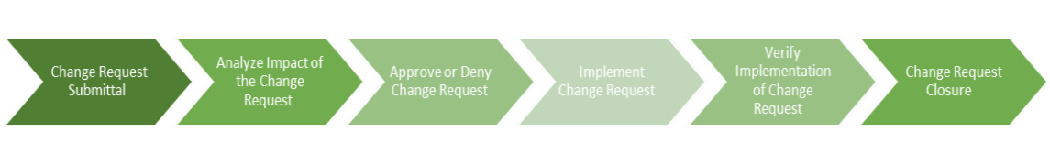

*Figure 6.6—1: Change Control Process (High Level)*

|  |  |  |
| --- | --- | --- |
| **Process step** | **Description** | **Change Log Status** |
| Change request submittal | 1. The **Requestor** fills out and submits the  change request form to initiate the request. If the requestor is unaware of how to properly fill out the form, the **Project Manager** will orient the requestor in completing the Change Request. | Submitted |
| Analyze Impact of the Change  Request | 1. After receiving the request, the **Project**  **Manager** will assess the impact of the change  request, whether it’s high or low, based on the scope, schedule, budget, quality and then determine the required action to implement. 2. If the impact is high, the **Project Manager** will then prepare a recommendation to approve | In Review |

|  |  |  |
| --- | --- | --- |
|  | or deny the change request based on the findings made during impact analysis. The **Project Sponsor** will then review the change request, the project manager’s, impact analysis and recommendation. If the impact is low, the Project Manager can decide to approve or deny the change request.  3. The **Change Coordinator** will update the  Change Log and create a Change Status Report. |  |

|  |  |  |  |
| --- | --- | --- | --- |
| Approve  Deny Change  Request | or | Approval of the change request depends on the impact it has on the project:     1. **Low Impact**   1. If the change request is low, the **Project Manager** has the authority to approve or deny the request.   * 1. If approved, the Project Manager will proceed with the "Implement Change Request” phase.   2. If denied, the change request is determined as closed.  1. The Change Coordinator will update the Change Log and create a Change Status Report.     2. **High Impact**   1. If the change request is high, the **Project Sponsor** has the sole authority to approve or deny the request.    1. If approved, the **Project Manager** will proceed with the "Implement Change Request” phase.    2. If denied, the change request is determined as closed. 2. The **Change Coordinator** will update the Change Log and create a Change Status Report. | Approved or denied |
| Implement  Change  Request | | 1. After the change log is updated to “Approved”, the **Project Manager** will create an action plan to implement the change request. 2. Once the action plan is finalized, the **Project Manager** will communicate the action plan and assign responsibilities to the team involved 3. The **Project Manager** then updates the project plan, budget, and schedule as needed. 4. The **Change Coordinator** will update the  Change Log and create a Change Status Report. | In Progress |
| Verify  Implementation of Change Request | | 1. **Project Manager** verifies that the change   has been implemented and reports to the Change Control Board.   1. The **Change Coordinator** will update the   Change Log and create a Change Status Report. | Verifying |
| Change Request  Closure | | 1. The **Change Coordinator** will send out the final the Change Status Report across the team and stakeholders. | Closed |

*Table 6.6—3: Change Request Process*

To keep track of the change request progress, each step has a corresponding change request status as show on the table below:

|  |  |
| --- | --- |
| **Status** | **Description** |
| Submitted | A member of the project development team or key stakeholders submitted a change request log and has not been reviewed by the Project Manager for impact analysis. |
| In Review | Impact analysis is being performed. |
| Approved | Change request is approved and will be moved to implementation. |
| Denied | Change request is denied. |
| In Progress | Action plan to execute the change request is being implemented |
| Verifying | Review of proper implementation of change request |
| Closed | Chang request work is complete, has passed all tests, and updates have been released. |

*Table 6.6—4: Change Request Status Description*

## 6.7. Communications Management Plan

6.7.1. Introduction

The Communications Management Plan is a critical component of the Dispatch Directory System project as it outlines the communication strategy and protocols for the project team and stakeholders. The plan defines the following:

1. The plan outlines the type of information that will be communicated, such as project updates, progress reports, risks, and issues. It also includes the level of detail and format of the information, such as whether it will be communicated verbally or in written form.
2. The plan outlines the methods of communication that will be used, such as meetings, email, telephone, web portal, etc. This ensures that all stakeholders are informed in a timely manner.
3. The plan outlines the frequency of project communications, both formal and informal, to ensure that stakeholders are kept informed on a regular basis.
4. The plan defines the roles and responsibilities of team members and stakeholders in terms of communication, including who is responsible for disseminating project information.
5. The plan outlines the specific communication needs of all stakeholders and how they will be met, such as language requirements and accessibility.
6. The plan outlines the resources allocated for communication, such as budget and personnel, to ensure that communication is effective and efficient.
7. The plan outlines the protocols for communicating sensitive or confidential information, including who must authorize the release of such information.
8. The plan defines a process for managing changes in communication or the communication process, including how changes are proposed, reviewed, and approved. This ensures that all stakeholders are aware of any changes and that the communication process remains consistent throughout the project.
9. The plan outlines the flow of communication within the project, including how information is shared between team members, stakeholders, and other project partners. This helps to ensure that all stakeholders are informed, and that information is shared in a timely manner.
10. The plan identifies any internal or external constraints that may affect project communications, such as legal or regulatory requirements, and outlines how these constraints will be addressed.
11. The plan outlines any standard templates, formats, or documents that must be used for communicating project information, such as progress reports or meeting minutes. This ensures that all stakeholders are provided with consistent and accurate information.
12. The plan includes an escalation process for resolving any communication-based conflicts or issues that may arise during the project. This helps to ensure that any communication-related issues are addressed and resolved in a timely manner.

Overall, the Communications Management Plan is a key tool that helps to ensure that all stakeholders are informed, and that communication is effective and efficient throughout the Dispatch Directory System project.

6.7.2. Communications Management Approach

The best communications management approach for the Dispatch Directory System project would be a combination of proactive and reactive strategies.

Proactively, regular project status meetings will be held to ensure all stakeholders are informed and aware of the project’s progress. The project manager will hold regular meetings with the project team and communicate any updates, progress reports, risks, and issues. This will provide stakeholders with an overview of the project’s status and any potential roadblocks. Additionally, a project website and web portal will be created to provide stakeholders with easy access to project information, such as meeting minutes, documents, and project status reports.

Reactively, a clear and concise escalation process will be established to address any communication-based conflicts or issues that arise. The project manager will be readily available to stakeholders to answer any questions or concerns they may have and provide support and guidance when needed.

In addition, a change control process will be implemented to manage any changes in communication or the communication process. This will ensure that any changes are approved by the Change Control Board and that stakeholders are informed of any changes in a timely manner.

Overall, this approach ensures that the project team and stakeholders are kept informed and that any communication-based issues are handled in an efficient and effective manner.

6.7.3. Communications Management Constraints

The Communications Management Constraints for the Dispatch Directory System project are a crucial aspect of the overall project management plan. These constraints help to define the limitations and boundaries that may impact the communication processes and strategies of the project. By identifying and addressing these constraints, the project team can proactively develop solutions to mitigate potential challenges and ensure the smooth flow of information throughout the project.

This section of the Communications Management Plan will provide an overview of the key constraints that may impact the project's communication processes, including internal and external factors, technological limitations, and regulatory requirements.

Communications management constraints for the Dispatch Directory System project may include:

1. **Limited budget for communication tools and resources:** The project may have a limited budget for communication tools and resources, such as video conferencing software, project management software, or hiring a dedicated communications team.

1. **Limited access to certain stakeholders:** Some stakeholders may be located in remote locations or have limited access to certain forms of communication, such as email or internet.

1. **Limited availability of team members:** Team members may have other commitments or responsibilities that limit their availability for communication.

1. **Language barriers:** If team members or stakeholders speak different languages, there may be a need for translation services or additional resources to facilitate communication.

1. **Confidentiality:** Some information related to the project may be confidential and require special handling and communication protocols.

1. **Resistance to change:** Some stakeholders may be resistant to changes in communication processes or tools, which can make it difficult to implement new communication strategies.

1. **Technical difficulties:** Technical difficulties with communication tools and systems can also be a constraint.

1. **Time constraints:** The project may be under a tight deadline, which can make it challenging to schedule and hold regular communication meetings.

6.7.4. Stakeholder Communication Requirements

The Stakeholder Communication Requirements are a vital component of the Dispatch Directory System project as they outline the specific communication needs of all stakeholders involved in the project. Effective communication is essential for ensuring that the project is completed on time, within budget, and to the satisfaction of all stakeholders. By identifying and addressing the communication requirements of stakeholders, the project team can proactively manage expectations, build trust, and foster collaboration.

This section of the Communications Management Plan outlines the specific communication needs of stakeholders and how they will be met throughout the project's lifecycle.

The stakeholder communication requirements for the Dispatch Directory System project would likely include:

1. **Regular project updates:** All stakeholders should be informed of the project's progress, including any issues or risks that may arise.
2. **Clear and concise communication:** All project-related information should be communicated in a clear and concise manner, ensuring that stakeholders understand the message.
3. **Accessibility:** Communication should be accessible to all stakeholders, considering any language or accessibility needs.
4. **Timely communication:** Information should be communicated in a timely manner, ensuring that stakeholders are informed as soon as possible.
5. **Confidentiality:** Any sensitive or confidential information should be communicated to only the necessary stakeholders and handled in a secure manner.
6. **Customized communication:** Communication should be tailored to the specific needs of each stakeholder, considering their level of involvement in the project and their role.
7. **Two-way communication:** Communication should be a two-way process, allowing stakeholders to provide feedback and ask questions.
8. **Feedback mechanisms:** A mechanism for stakeholders to provide feedback on the communication process should be in place to ensure that communication is effective.

6.7.5. Roles

|  |  |
| --- | --- |
| **Roles** | **Responsibilities** |
| Project Sponsor | A high-level executive who provides financial resources and strategic direction for the project. |
| Program Manager | A person responsible for overseeing the Dispatch Directory System and ensuring that it aligns with the organization's overall goals and objectives. The program manager might oversee multiple related projects within the organization. |
| Key Stakeholders | Individuals or groups who have a vested interest in the Dispatch Directory System, such as CREST team members, TELUS managers, and technicians who rely on the system for their daily operations. |
| Project Manager | The person responsible for planning, executing, and closing the Dispatch Directory System. The project manager leads the project team and ensures that the system is completed on time, within budget, and to the required quality standards. |
| Development Team | A person responsible for the technical aspects of the Dispatch Directory System, such as the system architecture, database design, and software development. The team ensures that the system meets the required technical specifications and standards, and that it is scalable, secure, and reliable. |

*Table 6.7—1:Communication Management Roles and Responsibilities*

6.7.6. Project Team Directory

The following table presents contact information for all persons identified in this communications management plan. The email addresses and phone numbers in this table will be used to communicate with these people.

|  |  |  |  |  |
| --- | --- | --- | --- | --- |
| **Name** | **Position** | **Internal, External** | **Project Role** | **Contact Information** |
| Mir Tolentino | Manager of Operations | Internal | Project    Sponsor | mir.tolentino@telusinternational.com |
| CREST Team | Team | Internal | Internal User    of the system | CREST@telus.com |
|  | Members  of  Operations |  |  |  |
| TELUS Technicians | Technicians, Customers | External | External user of the system | Cablerepair@telus.com |
| TELUS Managers | Managers, Customers | External | External user of the system | cnoemanagers@telus.com |
| Roselyn Angeles | Consultant | External | Project  Manager | roselyn.angeles@telusinternational.com |
|  |
| - | Junior Developer | Internal | Development  Team | - |
| - | Senior Developer | Internal | Development  Team | - |
| - | Quality  Assurance  Analyst | Internal | Development    Team | - |

*Table 6.7—2: Project Team Directory*

6.7.7. Communication Methods and Technologies

The Dispatch Directory System project requires a thorough understanding of the various communication methods and technologies that will be used to effectively communicate with all stakeholders. It is important to consider the different capabilities and limitations of each communication method and technology, in order to ensure that all stakeholders receive the information they need in a timely and efficient manner. This includes determining the appropriate methods for delivering project updates, progress reports, risks, and issues, as well as any other relevant information.

Additionally, it is important to consider the cost and feasibility of using different technologies, as well as any security or privacy concerns that may arise. By carefully selecting the most appropriate communication methods and technologies, the project team can ensure that all stakeholders are kept informed and that the project's communication objectives are met.

When determining the best communication methods and technologies for the Dispatch Directory System project, several factors should be considered. These include:

* **The size and complexity of the project: For** large and complex projects, web portals and project management software may be the best option as they allow for the centralization of information and easy access for all stakeholders.
* **The location of stakeholders:** For stakeholders that are in different geographical areas, video conferencing and telephone may be the best option as they allow for real-time communication.
* **The level of technical expertise of stakeholders:** For stakeholders that are not technically proficient, simple communication methods such as email and telephone may be the best option.
* **The type of information being communicated:** For sensitive or confidential information, secure methods such as encryption and password-protected portals may be necessary.
* **The budget and resources available:** The communication methods and technologies that are chosen should be within the project budget and resources.

Based on these factors, it is recommended that the Dispatch Directory System project utilizes a combination of communication methods and technologies such as project management software, email, telephone, and video conferencing to ensure that all stakeholders are kept informed and that the project's communication objectives are met.

6.7.8. Communications Matrix

|  |  |  |  |  |  |  |
| --- | --- | --- | --- | --- | --- | --- |
| **Channel** | **From** | **To** | **Type** | **Frequency** | **Format Used** | **Delivery media** |
| Project  Planning | Project  Manager | Stakeholders | Meeting | Once Before the start of the project | Formal | Email |
| Release planning | Project manager, Project team | Stakeholders | Meeting | Once before start of the  project Updated when  necessary | Formal | Email |
| Sprint  Planning | Project manager | Project team | Meeting | Once every week | Informal | Google  Spaces |
| Management  processes | Project  manager, project team | Stakeholders | Artifact | Once Before start of the  project Updated when  necessary | Written  Document | Email,  Google  Spaces |
| Product backlog | Project manager | Project team | Artifact | Once every week | Written  Document | Google  Spaces |
| Project update | Project  Manager | Project team | Meeting | Once every week | Informal | Google  Spaces |

*Table 6.7—3: Communication Matrix*

6.7.9. Communication Flowchart

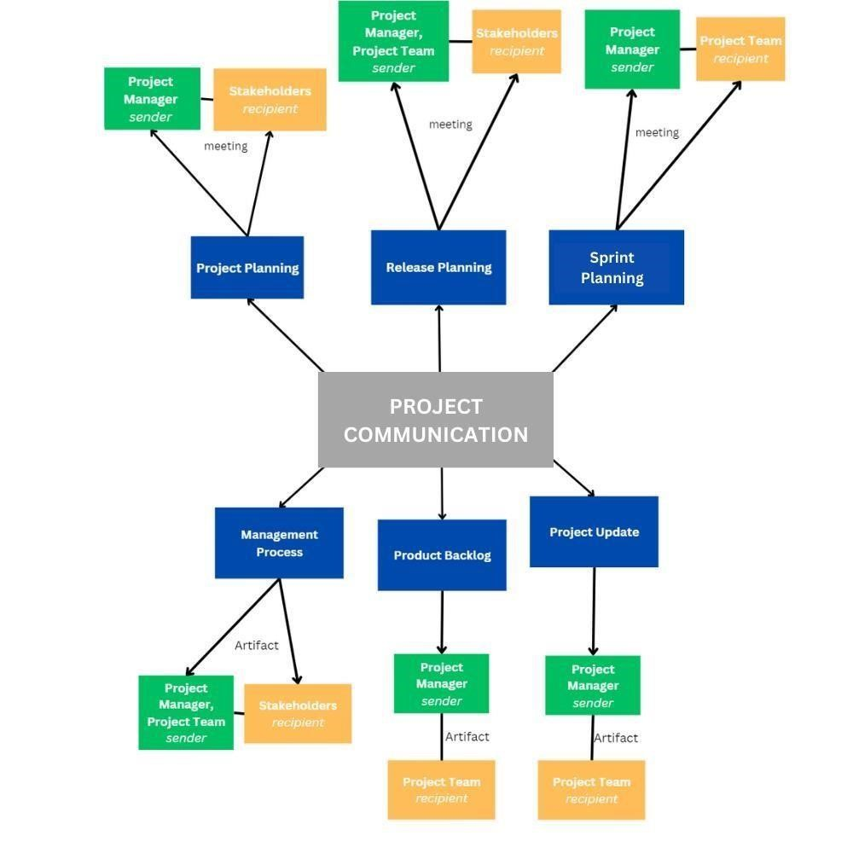

*Figure*

*6.7*

*—*

*1:*

*Communication Flowchart*

6.7.10. Guidelines for Meetings

Meetings are a key component of effective communication in any project. The Dispatch Directory System project is no exception. In order to ensure that meetings are productive, efficient, and effective, it is important to establish clear guidelines for meetings. These guidelines should include information on the purpose of meetings, the roles and responsibilities of attendees, and the procedures that will be followed during meetings.

By having a set of well-defined guidelines for meetings, project team members and stakeholders can be better prepared for the meetings and can participate more effectively in the discussions. Additionally, the project manager can ensure that meetings are conducted in a consistent and organized manner, which can help to avoid confusion and misunderstandings.

Below are the meeting guidelines for Dispatch Directory System project:

* **Purpose**: Meetings are an essential part of the Dispatch Directory System project and are used to discuss project progress, resolve issues, and make decisions.
* **Scheduling**: Meetings should be scheduled in advance and at a time that is convenient for all attendees. The project manager is responsible for scheduling meetings and sending out invitations.
* **Attendance**: All project team members and stakeholders are expected to attend meetings unless they have a valid excuse. If a team member is unable to attend, they should inform the project manager as soon as possible.
* **Agenda**: An agenda should be circulated in advance of the meeting, outlining the topics to be discussed and the expected outcome of the meeting. This will ensure that attendees are prepared and that the meeting stays on track.
* **Minutes**: Minutes should be taken during the meeting and distributed to all attendees within 24 hours. The minutes should include a summary of the discussions, decisions made, and action items assigned.
* **Decisions**: Decisions should be made by consensus whenever possible. If a consensus cannot be reached, the project sponsor has the sole authority to decide.
* **Action items:** Action items should be assigned during the meeting and a followup date set to ensure that they are completed on time.
* **Follow-up**: The project manager is responsible for following up on action items and ensuring that they are completed on time.
* **Communication**: Meetings are a means of communicating project progress and addressing issues. Attendees should be encouraged to communicate openly and honestly.
* **Technology**: Meetings should be held using technology that is accessible to all attendees. This may include video conferencing, teleconferencing, or web conferencing.
* **Time management**: Meetings should start and end on time and should not exceed the allotted time. This will ensure that attendees are not kept waiting and that the project stays on schedule.
* **Evaluation**: Meetings should be evaluated regularly to ensure that they are productive and that attendees are satisfied with the outcome. Any issues should be addressed and improvements.

6.7.11. Communication Standards

The best communication standards for the Dispatch Directory System project may include the following:

* **Standardized Templates:** Developing and using standard templates for project communications, such as status reports, meeting agendas, and minutes, can ensure consistency and clarity in the information being shared.
* **File Naming Convention:** Developing a standard file naming convention for documents and files shared on the project can help ensure easy access and organization of information.
* **Web Portal/Network Tool:** Utilizing a standard platform, such as SharePoint or project management software, for project communication can improve access to information and collaboration among team members and stakeholders.
* **Video conferencing:** Use of Video conferencing tools like Google Meets, Zoom, Skype, etc. can be very useful for team members and stakeholders who are located at different geographic locations.
* **Communication protocols:** Having a standard communication protocol in place for sensitive or confidential information, such as who is authorized to share it and how it should be shared, can ensure the protection of sensitive data.

6.7.12. Communication Escalation Process

The ideal and best communication escalation process for the Dispatch Directory System project would involve the following steps:

1. **Identify the issue:** The project team should first identify the communication related issue that needs to be escalated.
2. **Attempt to resolve the issue within the team:** The project team should make an initial attempt to resolve the issue within the team by discussing it with the relevant team members and trying to find a solution.
3. **Involve a communication manager:** If the issue cannot be resolved within the team, the team should involve a communication manager or a designated person responsible for communication within the organization. This person will act as a liaison between the project team and the stakeholders and help to resolve the issue.
4. **Escalate to higher management:** If the issue still cannot be resolved, it should be escalated to higher management for further review and resolution.
5. **Document the issue and resolution:** Throughout the escalation process, it is important to document the issue, the steps taken to resolve it, and the final resolution to ensure that proper records are kept for future reference.
6. **Review and Improve:** After the escalation process, review the process to identify what can be improved for future escalations.

It's important to note that the escalation process should be flexible and adaptable to the specific needs of the project. The project team should review the escalation process regularly to ensure that it remains effective and efficient in addressing communication related issues.

6.7.13. Glossary of Communication Terminology

|  |  |
| --- | --- |
| **Term Definition** | |
| **Communication Plan** | A document outlining the communication strategy and protocols for the project team and stakeholders. |
| **Stakeholder** | An individual or organization that has an interest or concern in the project. |
| **Communication Method** | The means by which information is conveyed, such as meetings, email, telephone, or web portal. |
| **Communication Frequency** | The regularity with which project communications are distributed. |
| **Communication Objective** | The desired outcome or goal of a particular communication. |
| **Communication Flowchart** | A diagram showing the flow of information within a project. |
| **Escalation Process** | A procedure for resolving communication-based conflicts or issues. |
| **Communication Matrix** | A table outlining the communication requirements for a project. |
| **Communication Standards** | Standard templates, formats, or documents used for communicating within a project. |
| **Communication Constraints** | Factors that may limit or affect the effectiveness of project communications. |
| **Communication Guidelines** | Protocols for conducting meetings, teleconferences, and other forms of communication. |
| **Communication Technology** | Tools and platforms used for communication, such as  SharePoint, message boards, and video teleconferencing. |
|  |  |
| **Communication**  **Escalation Process** | A process for escalating communication-based issues or conflicts that cannot be resolved within the project team. |
| **Communication Approaches** | Different strategies and solutions are implemented to address communication constraints, ensuring that all stakeholders are kept informed and that the project's communication objectives are met. |

*Table 6.7—4: Glossary of Communication Management Terminologies*

## 6.8. Quality Management Plan

6.8.1. Introduction

Quality Management Plan for the SurveiRams System is essential to maintain the project’s quality. With this guide, the team can evaluate the system for the betterment of it. Additionally, the plan has a framework for evaluating the quality.

Goals of the quality management plan:

* Make sure the project satisfies the expectations of the stakeholders.
* Indicate the quality standards that will be applied for evaluating the project.
* Clarify the roles and responsibilities of team members to meet quality standards.
* Identify and fix any potential quality issues.
* Make a plan for efficiently managing and upholding project quality over the length of the project.

The SurveiRams System will operate completely functionally, have a user-friendly interface, and be compatible with the organization's existing technology infrastructure. The Quality Management Plan will cover both the system and process quality standards. The plan will outline specific procedures, tools, and techniques for monitoring and reporting quality performance.

A quality management plan's tools include:

|  |  |
| --- | --- |
| **Definition of Done** | A clear explanation of what makes a finished product increment. |
| **Acceptance Criteria** | Criteria must be met for it to be approved by the project manager. |
| **Continuous Integration** | Regularly updates the code to make sure it is good for releasing. |
| **Test-Driven Development** | A way that emphasizes creating tests prior to writing code to ensure that the resulting code meets the desired quality standards. |

As a result, the quality management plan will establish a thorough framework for effectively managing project quality from start to finish. It will guarantee that the project satisfies and/or exceeds the expectations of stakeholders and offer a clear framework of processes, resources, and roles for identifying and resolving quality issues. It is necessary that everyone involved is aware of the plan and understands how they may contribute to its success.

6.8.2. Quality Management Approach

The Quality Management Plan for the SurveiRams project will utilize Hybrid Project Management which combines Scrum and Waterfall methodology to ensure that the project meets or exceeds all stakeholders' quality expectations. The approach will prioritize delivering high-quality products per work package and meeting customer requirements by following a step-by-step process.

The following are the roles and duties for the quality management plan:

|  |  |
| --- | --- |
| **Role** | **Description** |
| Project Manager | The Project Manager oversees establishing the standards and making sure the final product satisfies all stakeholders. |
| Project Team Leader | The Project Team Leader is responsible for ensuring that the team is following the Scrum framework and works with the Product Owner, Product Manager and Development Team to enhance the final product. |
| Project Development Team | The Project Development Team’s responsibilities include producing a high-caliber product and upholding the specified quality policies and standards. |
| Project Sponsor | Provides executive support and approval for the project. |

*Table 6.8—1: Quality Management Roles and Responsibilities*

Every aspect of the project will integrate quality management, involving the entire team. The team will aim to create a Minimum Viable Product (MVP) so that they may receive early feedback from users and thus improve the product.

The approach will include the following steps:

|  |  |
| --- | --- |
| **Set Quality Standards** | The project manager will define quality standards based on Agile and Scrum methodology, with a focus on delivering value to the client. |
| **Quality Planning** | The team will work closely with stakeholders to identify the requirements of the project and prioritize the most important features. To make sure that each version of the project complies with the set standards, the team will create a Product Backlog. |
| **Quality Control** | To identify issues or bugs, the team will conduct testing during each sprint to manage and control the quality of the project and meet its requirement or goal. |
| **Quality Assurance** | To avoid problems during the project, preventive measures will be implemented through quality assurance. The team will implement proper testing procedures to ensure that the project follows the set standards. |
| **Continuous Improvement** | To ensure continuous functionality of the project, the team will regularly monitor and assess its performance. They will gather feedback from stakeholders, identify areas that require improvement, and make necessary adjustments to enhance the overall quality of the project. |
| **Communication** | For the project to succeed, communication with the stakeholders is needed to give them awareness of the product’s status and have their feedback on it. |

A risk management strategy will be created to detect and mitigate any potential quality issues that may arise throughout the course of the project. Overall, the SurveiRams system's quality management approach will prioritize using Hybrid Project Management to provide a high-quality product that satisfies the intended client's criteria. To guarantee that the project meets or exceeds all quality requirements, the methodology will be adaptable and continually improved.

6.8.3. Quality Requirements / Standards

The SurveiRams System places an emphasis on high-quality requirements and standards; thus, the team will collaborate to develop and document them. The client's feedback, tests, and assessments will make sure that these criteria are followed. The following criteria and standards will be followed by the SurveiRams System project:

**Requirements for Product Quality:**

* Functionality: The SurveiRams System should fulfill its intended purpose and meet functional requirements specified by the Stakeholders and users. It should perform the task in an efficient manner.
* Reliability: The SurveiRams System should work consistently without issues, breakdowns or failures over sa specified period.
* Performance: The SurveiRams System should meet optimal performance and or exceed the expected standards.
* Design: The SurveiRams System should have an intuitive UI/UX where the users will have an easy time using the application.
* Compatibility: The SurveiRams System should be compatible with the existing devices of APC and its users. It should also be compatible with newer devices.
* Control: A control version of the system must always be available in case of issues.

**Requirements for Ensuring Quality of Processes:**

* Standardization: All processes must be well-defined and documented in a standardized manner to ensure consistency.
* Clear Roles and Responsibilities: Each individual should understand their roles and specific responsibilities.
* Continuous Improvement: Processes should be ongoing and always have room for improvement. The development team will apply feedback mechanisms and testing to figure out what parts of the project can be improved and what parts has issues.
* Monitoring: All proccesses must be monitored by the Project Manager, this will ensure the quality of the deliverables.

**Compliance Demonstration:**

* Before being delivered to the client, the SurveiRams System will go through extensive testing and evaluation to make sure it satisfies the necessary quality requirements.
* The development team will keep thorough records of all testing and quality assurance procedures, which the client can request.
* The customer will participate in a formal acceptance test to make sure the system satisfies their particular needs and expectations.
* To guarantee that the system continually complies with the defined quality requirements in the long run, the development team will offer ongoing support and maintenance services.

**Continual Improvement:**

The development team will set up a strategy for continuous improvement by routinely collecting and reviewing client feedback, monitoring system performance, and conducting internal reviews to identify potential improvement opportunities. They will also create a procedure for identifying and addressing any issues that may arise throughout the project. This comprises locating the issue, figuring out why it exists, coming up with a solution, and then evaluating how well it worked. These procedures will be used in the project to ensure that the SurveiRams System actively adapts to meet shifting client needs while maintaining the required level of quality.

6.8.4. Quality Assurance

To ensure quality is achieved through collaboration and continuous improvement, the SurveiRams Ticketing System project will integrate the QA process into the Agile and Scrum methodology. The following steps will be taken:

* **Defining Quality Standards:** The project team, in collaboration with stakeholders, will establish and document the quality standards in the Quality Management Plan. These standards will be effectively communicated to all stakeholders involved.
* **Agile Quality Auditing:** The project team will conduct quality audits on a regular basis utilizing Agile techniques including peer reviews, test-driven development, and continuous integration. These procedures will be used to determine whether the quality criteria have been met and to pinpoint areas that need improvement.
* **Quality Metrics:** The project team will employ quality metrics to monitor and report on the project's adherence to the defined quality standards.

To effectively monitor the quality process, the following metrics will be utilized:

* + - * Performance Metrics: Application Load time, Server Response time.
      * Usability Metrics: User Satisfaction, Task Completion Time, Error Rate.
      * Design Metrics: User feedback, UI/UX design feedback.
      * Scalability Metrics: Response Time under load, Resource Utilization (eg. RAM allocation, CPU Usage)
* **Continuous Improvement:** To promote continuous improvement in both the product and the quality process, the project team will make use of feedback from metrics and quality audits. Stakeholder participation will be used to identify areas for improvement, and the necessary adjustments will be made.
* **Compliance with Industry Standards:** The project team will ensure adherence to relevant industry standards, including accessibility, security, and data privacy regulations. Regular audits will be conducted to verify compliance with these standards.
* **Reviewing Customer Feedback:** Regular reviews of customer feedback will be conducted to identify any issues or areas requiring improvement. This feedback will play a crucial role in informing the continuous improvement efforts and ensuring that the product aligns with customer needs and expectations.

The project will implement rigorous monitoring, tracking, and reporting of quality assurance metrics to ensure the delivery of a high-quality outcome. Any deviations from the established standards will be promptly reviewed and fixed. The project team will receive regular reports from the software application, which will capture relevant data for these metrics. The quality assurance process will undergo frequent reviews to identify opportunities for enhancement and implement necessary improvements. The objective is to ensure that the SurveiRams System meets the best quality standards, with close monitoring of all quality assurance metrics to guarantee project success.

6.8.5. Quality Control

In Hybrid project management which combines both Scrum and Waterfall methodology, the development process incorporates quality control measures to emphasize continuous testing and feedback. The Quality Control process for the SurveiRams Ticketing System project entails the following steps:

* **Continuous testing and feedback:** To find problems and make sure everything is in line with customer expectations, the project team will conduct regular testing and survey. Whenever possible, automation will be used such as online forms to collect feedback.
* **User Acceptance Testing (UAT):** At the end of each sprint, representative end users will undertake UAT to confirm that the system adheres to their requirements and expectations. Users' feedback will help determine what changes are required.
* **Compatibility Testing:** A variety of platforms, including mobile devices and personal computers, will be used to test the SurveiRams System in order to assure compatibility and identify any issues that may arise in various settings.
* **Continuous Monitoring:** The project team will carefully assess the success of the system after deployment, concentrating on key performance metrics including user happiness, response time, and system uptime. This information will help with system improvements, problem identification, and bottleneck removal.

The following quality metrics will be utilized to monitor and evaluate system performance:

* Defect Severity: Classification of defects based on their impact on the system.
* Test Coverage: Percentage of the system subjected to testing.
* Test Case Pass Rate: Percentage of test cases successfully executed.
* User Happiness: Measured through surveys and user feedback.
* Response Time: Duration for the system to respond to user requests.
* System Uptime: Percentage of time the system is available and functioning as expected.
* **Monitoring and Documenting Quality Assessments:** The project team will diligently track and record the results of the Quality Control process, enabling ongoing monitoring of the project's advancement and the impact of any corrective measures implemented. Thorough documentation will provide valuable insights into the project's quality status.
* **Continuous Improvement:** The Quality Control process will undergo regular reviews to identify areas for enhancement and embrace opportunities for improvement. The project team will proactively seek out avenues to refine the process and swiftly incorporate necessary adjustments. This commitment to continuous improvement ensures that the Quality Control process remains adaptable to evolving requirements and industry best practices.

In conclusion, the SurveiRams Ticketing System project's Quality Control process will be deeply integrated into the development cycle, encompassing continuous testing, user feedback, and performance monitoring. The project team will vigilantly evaluate and maintain product quality, ensuring alignment with established standards and customer expectations.

6.8.6. Quality Control Measurements

The SurveiRams Ticketing System project will leverage a Hybrid Project management metholody to foster continuous inspection and adaptation throughout its lifecycle, promoting a transparent and collaborative approach to quality control. Quality control measures will be implemented at each stage of the development process and documented on a shared, accessible platform, replacing static spreadsheets or tables.

The platform will include essential details such as the measurement date, type of measurement (e.g., defect density, error rate, performance metrics, usability metrics, design metrics and scalability metrics), team member responsible for measurement, team member assessing the results, corrective actions taken, completion date of remedial measures, and team member responsible for their implementation.

Real-time dashboards such as OpenProject and visual tools will be utilized to track quality control metrics, enabling all team members to access and understand the data easily. These dashboards will highlight patterns and areas of concern, facilitating prompt action and necessary adjustments.

Regular team reviews, including sprint reviews and retrospectives, will entail the review of quality control metrics and allow for adjustments to the process as needed. Collaboratively, the team will identify potential areas for improvement and implement necessary changes.

In summary, the SurveiRams Ticketing System project will adopt Hybrid Project Management to establish a collaborative and dynamic quality control strategy. Continuous assessment of the product's quality will be performed, with regular improvements implemented. All quality control measurements will be collected and tracked on a shared platform in real-time. The team will collaborate to address any issues and drive necessary enhancements.

## 6.9. Risk Management Plan

6.9.1. Introduction

SurveiRams is a mobile application designed to develop a centralized system for Asia Pacific College’s (APC) Information Technology Resources Office (ITRO), Management Office (BMO), and Security Office. The application will assist them in managing incident reports and logs as well as provide insights.

The Risk Management Plan is important for projects following the Agile Methodology to use as a guide on how to identify and respond to risks. The team must enumerate potential risks, plan for responses, and monitor and control said risks from the project’s start to finish. Upon completion, the plan will be used every day, and may be revised to fit the project’s needs better, thus ensuring that the objectives of the project are achieved on time within budget.

Contents of this document include a summary of the risk management process, describing the sequence of steps as well as who is assigned to do so. Next is a guide for what constitutes as a risk and their hierarchy. Followed by this is the monitoring and controlling process for the risks, and last is the risk register.

To further develop a risk management plan for the SurveiRams System, the following information should be considered:

6.9.2. Top Three Risks

Every project has risks whether foreseen or not. However, in the situation of the SurveiRams project, the three biggest foreseen risks are the following:

1. **Technical Risks** – Risks that are brought by evolving technology, such as failure from either or both software and hardware and cyberattacks resulting in data loss and/or security breaches.
2. **Insufficient Resources** – Risks that are brought by the lack of project resources such as exceeding the project timeline or going over budget, which may delay the completion.
3. **Human Error** – Risks that are brought by the unavoidable mistakes made by humans involved in the project such as the project team, stakeholders, and personnel.

6.9.3. Risk Management Approach

Agile risk management values lean thinking and efficient communication. This means that for the SurveiRams risk management strategy, the focus will be data gathering and analysis before deciding on a course of action. Stakeholders, sponsors, and the project team must cooperate with each other for the risk management approach.

Specifically, these are the steps to be followed:

* **Risk Identification:** Meetings will be held to discuss relevant risks encountered based on experience from other projects, and a Risk Register will be put together.
* **Risk Assessment:** A Risk Assessment Matrix will be constructed to rank the risks discussed based on the probability of their occurrence as well as the gravity of its impact on the project.
* **Risk Mitigation:** Mitigation plans will be made for the risks that have a high probability and extreme gravity, which include how to prevent them and minimize their impact.
* **Risk Monitoring:** There might be unforeseen risks that could arise. To be ready to minimize or eliminate them, there will be a bi-monthly examination of the Risk Register, as well as another round of brainstorming for possible risks that haven’t been discussed. New risks discovered will be added to the Risk Register.
* **Risk Communication:** All stakeholders must regularly keep contact to be informed about the occurrences of risks and how they are handled. They must also be updated regarding changes in the risk management plan and process.

6.9.4. Risk Identification

After a thorough discussion with the project team, risks to SurveiRams were identified. The team organized these risks into the following categories:

* **Technical:** Risks related to technology
* **Cost:** Risks related to the project budget
* **Schedule:** Risks related to the project timeline
* **Communication:** Risks related to communication among all stakeholders
* **Skills Resource:** Risks related to the project team’s skills and expertise
* **External Hazard:** Risks related to nature, society, and the government

These are all the possible types of risks that could affect the project. Updates will be made in the event that another type is discovered. Specific risks under some of these categories will be discussed in the Risk Register below.

6.9.5. Risk Qualification and Prioritization

6.9.6. Risk Monitoring

A Risk Assessment Matrix based on probability and impact was created to aid in ranking the risks in the Risk Register.

Table 1. Risk Assessment Matrix

|  |  |  |  |
| --- | --- | --- | --- |
|  | 1 | 2 | 3 |
| 1 | Low | Low | Medium |
| 2 | Low | Medium | High |
| 3 | Medium | High | High |

As shown in Table 1, there are three levels each for the probability and impact of a risk. The lowest level is 1 and the highest is 3. The assessments are the following:

* Low – These are risks with low impact and low probability. Risks assessed as low are negligible and are low priority.
* Medium – These are risks with medium impact and probability. Risks assessed as medium must have mitigation plans at least drafted, and these are medium priority.
* High – These are risks with high impact and probability. Risks assessed as high must have finalized and strong mitigation plans ready and studied by the project team, as these are of high priority.

6.9.7. Risk Mitigation and Avoidance

A Risk Register was made for the project team to have a centralized guide to refer to upon encountering risks. This will be disseminated to all the stakeholders for easy access, so they can be prepared with their tasks and responsibilities when the time comes. Although there are numerous risks that could possibly happen, only the five most likely ones to occur for the SurveiRams project are listed below.

6.9.8. Risk Register

Table 2. Risk Register

|  |  |  |  |  |  |
| --- | --- | --- | --- | --- | --- |
| **Risk ID** | **Risk Category** | **Risk Description** | **Risk Assessment** | **Owner** | **Mitigating/Avoiding Action** |
| 01 | Technical | Data loss | High | Developers | Create backups for the data such as exporting the database contents into a document |
| 02 | Technical | System Bugs | Medium | Developers | Revisit and debug source code |
| 03 | Technical | Power Failure | Medium | Project Manager | Activate backup electricity generators |
| 04 | Technical | Unstable Internet Connection | Medium | Project Manager | Buy load to use mobile data |
| 05 | Cost | The project goes over budget | Low | Project Manager | Request for additional budget from Project Sponsors |

Table 2, the Risk Register, shows the following information that are needed for managing the risks identified:

1. **Risk ID** – The unique identifier assigned to each risk.
2. **Risk Category** – Each risk is labelled based on the categories listed in Risk Identification it falls under.
3. **Risk Description** – The explanation of what the risk is and its effects.
4. **Risk Assessment** – The assessment of the risk based on the Risk Assessment Matrix.
5. **Owner** – The person/s responsible for taking action for each risk.
6. **Mitigating/Avoiding Action** – Indicates the steps needed to be done by the Owner to mitigate or avoid the risk. Risks assessed as low will have Avoiding Actions, while those assessed as high will have mitigating actions.

When a risk occurs, the Owner must inform all stakeholders between 24-48 hours depending on its impact. Next, they must send a Risk Mitigation Request Form (found in Appendix A) to the Project Sponsors containing the Risk ID, incident, cause, their plan to mitigate the risk, and request for the resources they need to do so. The Project Sponsors shall review the report and approve or provide the requested resources so that the Owner may proceed in mitigating the risk.

In case the system is down due to any risk except when there is no internet connection, the contingency plan is to use Microsoft Forms. The security guards may log their incident reports there instead of going back to manually writing in their log books. When the system is running again, the team can simply download the form’s responses and add it to the database. Another option is to input the details in the application.

## 6.10. Procurement Plan

6.10.1. Introduction

The project's success depends on the Procurement Management Plan. This plan outlines the project's procurement needs and describes how the process will be handled from the production of procurement papers to the signing of agreements. This plan aims to ensure that all necessary materials are purchased on schedule, within the allotted budget, and at the required quality level for the project. This plan outlines the kind of things that must be purchased, the justifications and deadlines to meet, the contract types to be employed, the risks associated with procurement management, and how these risks will be handled. Additionally, it explains how to calculate costs and assess vendors, including how to use templates and other common procurement methods.

This plan also includes managing vendors, a vital element in the procurement process. In addition, it identifies any qualified sellers if necessary. The plan includes performance metrics for procurement operations in order to guarantee that the procurement procedure is monitored and controlled throughout the project's life cycle.

To summarize, the Procurement Management Plan’s objective is to have an efficient and effective completion of the project’s procurement requirements while giving priority to the quality, cost, and schedule. This management provides a roadmap of the procurement process, for stakeholders to be aware and informed of what is happening in the development.

6.10.2. Procurement Risks

Procurement in every project is a vital component that should be taken with care because it involves budget in acquiring goods, services or work from external sources. Having risks in the procurement may negatively impact the development. Therefore, it is an issue that should be addressed to minimize the impact on the project.

The SurveiRams System incorporates procurement processes that entail a number of hazards, including but not exclusive to the following:

* Delivery of services or goods within the project timeline from vendor may result in increased costs.
* The absence of competition in the market may lead to higher prices or reduced quality of services.
* Commitments with the vendor and procurement activities may be compromised when there is a sudden change in the project scope, schedule or budget.
* Misunderstandings between the project team and the vendor may arise when there are no clear specifications, lack of documents and incorrect assumptions.
* Poor communication with the vendor may lead to misunderstandings.
* Vendor does not comply with the regulatory requirements or legal issues, which may impact the project, team and stakeholder’s reputation.
* Inadequate vendor selection or evaluation may result into partnering with unreliable sources that has a low quality of goods or services.
* Contract management oversight may lead the vendor’s services or goods and the project team’s development to fail.

To mitigate these risks, the Procurement Management Plan includes detailed strategies for risk identification, assessment, and mitigation. The team will consistently monitor the plan throughout the project’s duration to specify and address the risks. Moreover, the team will impose accurate procurement processes to control the potential risks associated with procurement management.

6.10.3. Procurement Risk Management

1. Identification of Procurement Risks

The first step in managing procurement risks is to identify and assess them. For the SurveiRams System, potential procurement risks include:

* + Unexpected increase in the cost of goods or services
  + Delays in the delivery of goods or services
  + Incomplete or substandard goods or services
  + Unclear or insufficient contract terms and conditions
  + Misalignment of the vendor’s goals with the project
  + Inaccurate estimates of costs and timelines
  + Insufficient supplier qualifications
  + Non-compliance service/goods with applicable laws or regulations
  + Supply Chain disruptions
  + Data breaches
  + Contract Disputes/Payment Issues

1. Risk Mitigation Strategies

After identifying the potential procurement risks, it is ideal to plot a strategy to mitigate them. For the SurveiRams System, the following risk mitigation strategies will be put into action:

* + Regularly monitoring and evaluating the vendor’s performance to ensure that they adhere to the project and the team’s standards and also to the laws and regulation standards.
  + Implement an effective contract management practice to prevent vagueness and ensure clear information.
  + Conducting research in the market to identify lists of reliable vendors with a good track record in delivering high-quality goods or services.
  + Establishing a clear delivery schedules, specifications and performance criteria for the procurement plan.
  + Developing a comprehensive contract terms and conditions that protects the interests of the project and the team.
  + Having a contingency plan to address potential vendor bankruptcy.
  + Conducting a regular risk assessment in the procurement process to identify and address emerging risks.
  + Conduct thorough market research and maintain up-to-date information on market trends and prices.
  + Diversify the supply chain by having multiple suppliers to have an alternative if a supply chain disruption happens.

1. Assignment of Responsibilities

Every person in the team should be given a clear assignment of duties for controlling procurement risks. The procurement manager will be in charge of identifying and evaluating procurement risks for the SurveiRams System, creating risk mitigation plans, and keeping an eye on risk throughout the procurement process.

Project manager and the team’ s input and feedback on procurement risk management strategies are also valuable and essential.

1. Communication and Reporting

Communication and reporting in the process of procurement risk management is valuable. The regular updates on the procurement risks and risks mitigation activities will be provided to the team. Communication within the team may be held using online platforms if necessary.

Moreover, communication plan is developed for the stakeholders to keep informed in any changes or developments made in the procurement risk management.

1. Continuous Improvement

To improve future procurement planning and execution, lessons acquired from risk management and procurement operations will be recorded and communicated to the project team. It should be a constant practice to improve procurement risk management.

In order to identify areas for improvement, procurement risk management operations will also be regularly reviewed.

6.10.4. Cost Determination

Determining costs is a key component of the SurveiRams System procurement process. The team will employ a thorough cost determination procedure to choose providers who are both competent and cost-efficient. As part of the cost estimation process, potential suppliers are asked to submit quotes, proposals, or bids in response to an RFP (Request for Proposal). The team must assess the costs related to the procurement process, such as acquisition, delivery, installation, and maintenance costs. The group will evaluate potential cost overruns as well as suggest measures to reduce them. To promote openness and equity in the selection process, the project team will make cost one of the primary deciding factors.

The cost determination process will involve a number of stakeholders, such as procurement managers, project managers, financial analysts, project sponsor and team adviser. These parties will work together to make sure that the procurement budget is continuously tracked and that all expenditures are accurately estimated. The project team will use standardized procurement templates and papers to speed up the cost estimation procedure. This will make it easier to guarantee that all cost estimates are accurate and consistent across all procurement operations. The project team will also construct procurement performance measures to evaluate the efficiency of the cost estimation procedure.

Overall, the procurement management plan's cost determination section will be extremely important in ensuring that the SurveiRams System is completed successfully and within the allotted budget.

6.10.5. Procurement Constraints

The following constraints must be considered as part of the SurveiRams project’s procurement management process:

1. **Budget Constraint:** The project must be completed within a specific budgetary limit. This constraint restricts the team’s flexibility as the project must be aligned with the available financial resources.
2. **Time Constraint:** The project must be delivered within a specified timeframe. This constraint limits the development and deployment according to the project schedule, meeting the required deadlines.
3. **Quality Constraint:** The project must meet certain quality standards and performance expectations. This constraint limits the team to finding suppliers that meet the quality standards needed for the project.
4. **Technical Constraint:** The project must adhere to specific technical specifications or compatibility requirements. This constraint restricts the team’s performance due to lack of tools, sub-standard equipments and bad quality of goods/tools.
5. **Security and Compliance Constraint:** The project must comply with relevant security standards, data protection regulations, and industry-specific compliance requirements. This constraint limits the user confidence in using the application as the system lacks the security standards nec
6. **Scalability Constraint:** The project must be scalable to accommodate future growth and increased user demand. This restricts the whole project team due to vendors that can’t provide the required goods/tools for the project.

These constraints must be considered throughout the procurement process to ensure that the SurveiRams project's requirements are met within the project's timeline and budget constraints.

6.10.6. Contract Approval Process

The contract approval process for the SurveiRams project will follow a systematic and organized approach to ensure the timely and effective approval of all contracts. The process will adhere to the organization's policies and procedures and encompass the following stages:

1. **Initiation:** The project sponsor or requester identifies the need for a web application and initiates the contract approval process. This includes documenting the project requirements, objectives, and expected outcomes.
2. **Preparing the Request for Proposal (RFP):** The project team, in collaboration with the procurement department, prepares a detailed Request for Proposal (RFP). The RFP includes project specifications, technical requirements, timeline, budget, evaluation criteria, and any other relevant information.
3. **Vendor Selection:** The procurement department issues the RFP to potential vendors and suppliers. Interested vendors submit their proposals, which are evaluated based on predetermined criteria such as experience, technical capabilities, price, references, and compliance with security and regulatory requirements.
4. **Proposal Evaluation:** The project team reviews and evaluates the proposals received. They assess each proposal based on the defined evaluation criteria and shortlist the vendors that best meet the project requirements.
5. **Contract Negotiation:** The project team engages in contract negotiation with the selected vendor(s). This includes discussing terms and conditions, pricing, scope of work, service-level agreements, intellectual property rights, data protection, and any other relevant contractual aspects.
6. **Contract Approval:** The revised contract is submitted for final approval to the designated authority, such as a project steering committee, management team, or legal department. The approval authority carefully reviews the contract, considering factors such as budget, alignment with organizational objectives, legal compliance, and risk assessment.
7. **Signatures and Execution:** Once the contract receives final approval, both parties (the company and the vendor) sign the contract, acknowledging their agreement to the terms and conditions. This may involve obtaining signatures from authorized signatories and stakeholders and storing the executed contract in a secure repository.
8. **Contract Management**: After contract execution, a contract management process is established to monitor the vendor's performance, ensure compliance with contractual obligations, track deliverables, manage changes, and handle any issues or disputes that may arise during the project implementation.

It's important to note that the contract approval process may vary depending on the organization's specific procedures, hierarchy, and approval authority levels. Therefore, it is advisable to adapt the process to align with your organization's unique requirements and internal policies.

6.10.7. Decision Criteria

For the SurveiRams project, the following decision criteria will be used by the contract review board:

* **Technical Expertise:** The vendor should possess the necessary technical skills and capabilities to successfully complete the project, demonstrating experience in similar projects and expertise in relevant technologies.
* **Pricing:** The vendor's proposed solution should have competitive and reasonable pricing, which will be evaluated based on market research and comparison with other received proposals.
* **Timelines:** The vendor must demonstrate the ability to meet the project's timeline and deliverables, including key milestones and completion dates.
* **Quality Assurance:** The vendor's track record should demonstrate a consistent delivery of high-quality solutions and services, supported by references and testimonials from previous clients.
* **Risk Management:** The vendor should exhibit a comprehensive understanding of potential risks and have effective risk mitigation plans in place. This includes identifying procurement-related risks as well as risks associated with project execution.
* **Sustainability:** The vendor's proposed solution should consider sustainability factors, including environmental, social, and economic aspects. This could involve utilizing eco-friendly materials or supporting local communities.
* **Compliance:** The vendor must comply with all applicable legal, regulatory, and contractual requirements, including intellectual property rights, data privacy, and security protocols.
* **Communication:** The vendor must exhibit excellent communication skills and be responsive to inquiries, concerns, and updates throughout the project lifecycle. Effective and open communication channels are essential for successful collaboration.
* **Scalability:** The vendor's solution should be scalable, allowing for future growth and adaptability to evolving business needs. This includes the ability to accommodate increased user demand, handle larger datasets, and integrate additional features seamlessly.
* **Innovation and Creativity:** The vendor should demonstrate a capacity for innovation and creativity in their proposed solution. This involves providing unique and forward-thinking ideas, leveraging emerging technologies, and offering insights to enhance the overall project outcome.
* **Team Expertise:** The vendor's team members should possess the necessary expertise and experience to contribute effectively to the project. Their qualifications, certifications, and relevant industry knowledge will be evaluated to ensure the availability of a skilled and capable team.
* **Collaboration and Flexibility:** The vendor should exhibit a willingness to collaborate closely with the organization's team, demonstrating flexibility in accommodating changes, feedback, and evolving project requirements. A collaborative approach fosters a productive working relationship.
* **Vendor Stability:** The vendor's financial stability, reputation, and longevity in the industry should be assessed. This helps ensure a reliable and sustainable partnership, reducing the risks associated with vendor instability or unforeseen business disruptions.

The criteria provided ensure that the decision-making process for selecting a vendor for the web application project is comprehensive and aligned with the organization's specific needs and priorities.

6.10.8. Performance Metrics for Procurement Activities

For the SurveiRams project, the following performance metrics will be used for procurement activities:

Supplier Performance:

This metric evaluates the performance of suppliers based on criteria such as on-time delivery, product quality, adherence to specifications, responsiveness to inquiries, and overall satisfaction of the procurement team and end-users.

Procurement Cycle Time:

Cost Savings: This metric measures the cost savings achieved through procurement activities by comparing the negotiated prices or discounts with market rates or previous prices. It helps determine the effectiveness of cost management strategies and identifies opportunities for further savings.

Supplier Diversity:

This metric assesses the diversity and inclusivity of the supplier base, tracking the percentage of contracts awarded to minority-owned, women-owned, veteran-owned, or small businesses. It promotes supplier diversity and supports social responsibility goals.

Contract Compliance:

This metric measures the extent to which suppliers adhere to the terms and conditions specified in the contracts. It evaluates factors such as timely delivery, quality of goods or services, invoicing accuracy, and compliance with regulatory requirements.

Risk Management:  
This metric evaluates the procurement team's ability to identify and mitigate risks associated with suppliers, such as financial instability, supply chain disruptions, regulatory non-compliance, or ethical concerns. It helps ensure supplier reliability and minimize potential risks.

Stakeholder Satisfaction:  
This metric measures the satisfaction levels of internal stakeholders, such as end-users, project managers, and finance teams, with the procurement process. It involves collecting feedback on factors like responsiveness, accuracy, timeliness, and overall experience.

Process Efficiency:  
This metric evaluates the efficiency of procurement processes, such as requisition processing, supplier selection, contract negotiation, purchase order creation, and invoice processing. It aims to identify areas for streamlining and automation to optimize efficiency.

Continuous Improvement:  
This metric assesses the procurement team's ability to drive continuous improvement initiatives. It tracks the implementation of process enhancements, cost reduction strategies, supplier performance improvement plans, and other improvement projects.

## 6.11. Implementation Plan

6.11.1. Executive Summary

The project team has created a transition out plan as part of the project closeout for the SurveiRams Ticketing System. This will enable a smooth transfer of ownership to the new owners. This plan's goal is to give a broad picture of the transition process, including the background of the contract, the system's current situation, and the anticipated transition to the new owners.

To improve their reporting processes, our team and the customer together developed the SurveiRams Ticketing System and accomplished the project's goals. According to the terms of the contract, ownership of the system has now been passed to the client.

The system is functioning and stable right now. The user training process has been finished, and all necessary functionalities have been tested and validated. As we leave, we want to make sure the client has access to all the information and assistance they need to efficiently manage and maintain the system.

To make sure the new owners have a thorough understanding of the system, all project deliverables will be given to them, including technical documentation, user manuals, and source code. Additionally, we will offer the new owners knowledge transfer sessions covering system operations, maintenance, and troubleshooting.

The project's transition out plan consists of a thorough schedule with an emphasis on a successful and flawless handover to the next contractor. User education will take place during the implementation phase of the transition plan, which will begin in the middle of April 2024. Documenting lessons learned, updating files and records, obtaining official acceptance, archiving files and papers, and convening a project closeout meeting are just a few of the crucial tasks that are included in the plan's closeout phase. The project closeout meeting is scheduled for the end of June 2024, following the completion of these tasks. The transition team will be working closely throughout the entire process to guarantee a seamless handover and reduce any disruptions to the project's operations. The team will be composed of a variety of members, including the project team members, developers, and the transition project manager. The project team hopes to achieve a successful and seamless handover to the new contractor while preserving the quality of the project's deliverables by following this transition strategy and timeframe.

The overall goal of the transition out plan is to guarantee that the client receives a fully functional and long-lasting system and that our team successfully completes the project.

6.11.2. Transition Approach

**General Approach:**

A phased strategy will be used to provide a seamless and uninterrupted transition for the SurveiRams Ticketing System Project, prioritizing continuity and causing the least amount of inconvenience possible. The goal is to carefully and methodically transfer knowledge, assets, and duties to the new team to reduce the possibility of service interruptions and downtime.

The project transition process encompasses the following stages:

1. **Identifying Key Variables:** A thorough understanding of the crucial elements, variables, or parameters relevant to the project will be established. This entails identifying critical components that have a big impact on the project's overall success.
2. **Roles to be assigned:** Each team member's precise roles and duties will be decided. This involves assigning specific tasks and explaining the roles and responsibilities of everyone involved in the project.
3. **Clarifying Responsibilities:** Each team member will have their duties clearly and concisely specified. This makes sure that everyone is fully aware of their own responsibilities and the standards expected of them.
4. **Work Delegation:** Tasks and activities will be assigned to team members who have the necessary knowledge and abilities. The delegation procedure makes sure that the task is distributed effectively and efficiently.
5. **Monitoring Project Progress:** The project's progress will be closely monitored to make sure that tasks and milestones are finished on time. This makes it possible to quickly identify any problems or delays and take immediate corrective action.
6. **Implementing Corrective Action:** Appropriate corrective steps will be performed in the event that there are any project-related difficulties or problems. This could entail changing the project schedule, reallocating resources, or making the necessary corrections to guarantee project success.

These processes are essential to the project management process because they enable efficient staffing allocation, knowledge transfer, effective communication, careful planning, and proactive progress monitoring.

**Timeline:**

The transition plan is divided into two primary phases:

**Implementation** **Phase** (April 18, 2024 – June 26, 2024)

* Identifying Key Variables: Apr 18 – Apr 26 (7 days)
* Determine Roles: Apr 29 – May 3 (5 days)
* Determine Responsibilities: May 6 – May 13 (5 days)
* Delegate the work/User Training: May 14 - May 31 (14 days)
* Progress Monitoring: June 3 – June 12 (7 days)
* Take Corrective Action: June 13 – June 26 (10 days)

**Closeout Phase** (June 27, 2024 – August 12, 2024)

* Finalizing project deliverables: June 27 – July 3 (5 days)
* Confirm Project Completion: July 4 – July 12 (7 days)
* Review all contracts: July 15 – July 23 (7 days)
* Reviewing Documentation: July 24 – Aug 12 (14 days)

The timeline offers a thorough schedule for every activity, making sure that all transitional activities are finished on time. The successful implementation of each task as specified in the timeline requires careful planning and scheduling.

**Assumptions:**

To facilitate the transition approach, the following assumptions will be made:

1. The Project Developers and Software Testers will actively participate in the transition process and receive knowledge transfer by being physically present on-site or available for online sessions.
2. To facilitate the knowledge transfer, the project team will give the Quality Assurance Lead all required documents, training materials, and instruction manuals.
3. The project team will receive the necessary hardware and software licenses from Asia Pacific College (APC) in order to maintain the system.
4. The project team is equipped with the necessary knowledge and abilities to maintain the system after the transition is complete.

6.11.3. Transition Team Organization

1. **Transition Project Manager (TPM):** The person responsible for the transition's overall success. The TPM manages the transition team, makes sure that tasks are finished on time, keeps communication open with the client, and ensures that the transition strategy is followed.
2. **Developers/Technical Lead (DTL):** Responsible for providing technical expertise throughout the project. To understand the system and create a transition strategy, the project team and the developers/technical lead work closely together. The TL also promotes communication with the new contractor to guarantee a smooth transfer of technical know-how.
3. **Software Tester Lead (STL):** Tasked with managing testing efforts, developing test plans, and maintaining software quality standards. To achieve a successful and efficient software testing process, the STL works closely with project managers, developers, and stakeholders.
4. **Quality Assurance (QA) Lead:** Liable for ensuring that all deliverables adhere to the quality requirements outlined in the transition plan. The TPM and the QA Lead collaborate closely to create quality measures and guarantee that all transition tasks are completed to a high standard.
5. **Project Team Members:** Accountable for offering assistance, information, and knowledge about the system. To ensure a smooth transfer of knowledge and skills, they collaborate closely with the TPM, developers, and other team members.

|  |  |
| --- | --- |
| Role | Responsibilities |
| Transition Project Manager | The person responsible for the transition's overall success. The TPM manages the transition team, makes sure that tasks are finished on time, keeps communication open with the client, and ensures that the transition strategy is followed. |
| Developers/Technical Lead | Responsible for providing technical expertise throughout the project. To understand the system and create a transition strategy, the project team and the developers/technical lead work closely together. The TL also promotes communication with the new contractor to guarantee a smooth transfer of technical know-how. |
| Software Tester Lead | Tasked with managing testing efforts, developing test plans, and maintaining software quality standards. To achieve a successful and efficient software testing process, the STL works closely with project managers, developers, and stakeholders. |
| Quality Assurance Lead | Liable for ensuring that all deliverables adhere to the quality requirements outlined in the transition plan. The TPM and the QA Lead collaborate closely to create quality measures and guarantee that all transition tasks are completed to a high standard. |
| Project Team Members | Accountable for offering assistance, information, and knowledge about the system. To ensure a smooth transfer of knowledge and skills, they collaborate closely with the TPM, developers, and other team members. |

*Table 6.11—1: Roles and Responsibilities*

6.11.4. Workforce Transition

The SurveiRams Ticketing System project's transition strategy places a lot of attention on the workforce transfer. A thorough workforce plan must be established and successfully communicated in order to guarantee a smooth and effective transition.

The Transition Project Manager will work closely with the customer, the existing and new contractors, as well as the transition team to decide on the best strategy for managing the workforce. This may include taking a variety of steps, including hiring new employees or transferring current employees to the new contractor.

In this process, timely and clear communication is essential because it's important to respectfully inform the workforce of any changes. The Transition Project Manager will make sure that all staff members are educated about their substitutes and receive the required support throughout the transition by collaborating closely with BMO, ITRO, and security management.

The employees will also receive any necessary training or retraining to ensure that they are fully prepared to provide great services both during and after the transition phase. With the ultimate objective of successfully completing the project within the allocated schedule and budget, the workforce transition plan will be subject to continuous assessment and adjustments as necessary.

6.11.5. Workforce Execution During Transition

During the transition period of the SurveiRams System project, several essential tasks will still need to be completed, which are as follows:

**User Training:** To inform users of the new system, training materials must be created and distributed. The training sessions would probably last two weeks and will combine classroom instruction with practical training.

**System Testing:** This signifies the official deployment of the new system. The team must make sure that every necessary component are in place and working properly before making it available to users. This will probably require performing final system tests and confirming the accuracy of the data migration.

**Documentation of Lessons Learned:** Documenting the project-related insights is part of this step. It comprises determining the team's strengths and weaknesses in order to make adjustments. The document will be a useful tool for next projects and encourage the use of best practices.

**Finalize Project Deliverables:** The group is in charge of updating relevant documents and records to reflect the project's completion. This can entail keeping copies of particular documents on hand or modifying contracts and agreements with new information.

**Formal Acceptance:** Getting the customer's formal approval during this phase signifies that the transfer was accomplished. The project team is responsible for making sure that all deliverables have been completed and that the customer is satisfied with the new system.

**Archiving Files/Documents:** All project-related files and papers will be archived during this time. Contracts, agreements, project plans, and other relevant documents may be included.

**Project Closeout Meeting:** A meeting with all stakeholders to close out the project is part of the transition's final phase. The purpose of this meeting is to discuss the project as a whole, identify areas for success and improvement, and ensure that any unresolved concerns are addressed.

6.11.6. Subcontracts

There are no existing contracts or subcontract agreements related to this project. Therefore, no transition of contracts or related agreements is required.

6.11.7. Property Transition

6.11.7.4. User Accounts and Passwords

The transfer of user accounts and passwords must be covered in the project's transition strategy for the SurveiRams Ticketing System. The following lists the concerns and actions for this specific transitional phase:

**User Account Inventory:**

• To start with, a thorough inventory that details every user account and its corresponding privileges must be made. System administrators, BMO, ITRO, and end users (security employees) are a few examples of internal and external users that should be included in this inventory. It should also indicate which accounts are no longer active or required by the system.

**Password Security:**

• Security must be maintained as the top priority during the transition process, so all user passwords must be reset or disabled. This action protects the system and the data it contains against unwanted access. Users should be informed to change their passwords to a temporary one issued to them before the switch. The system owner should then insist that all users create new, secure passwords during the transfer.

**User Database:**

• The database for all user accounts to be moved or disabled should be part of the transition plan. This table has to have information like the login, linked email address, and relevant access rights. It should also specify any special instructions for the transition, whether the account will be moved or disabled.

In summary, the transition of user accounts and passwords is a critical aspect of the property transition plan for the SurveiRams Ticketing System project. By implementing a comprehensive account inventory, prioritizing password security, establishing clear procedures for account transition and disablement, and providing a user account table, a seamless and secure transition can be achieved.

6.11.8. Knowledge Transfer

**Documentation/Manuals:**

• APC management, BMO, ITRO, and security staff will receive thorough documentation and manuals from the project team and senior developer.

• To improve APC management's knowledge of the system's operation, the documentation will include a project overview, system architecture, functional requirements, technical specifications, and other relevant documents.

• The guides will include thorough, step-by-step guidance on how to carry out particular system-related tasks.

**Training:**

• To achieve a complete understanding of the system and its operations, APC management will receive individualized training from the project team and senior developer.

• APC management will have access to online training materials and tools for the system's continued knowledge and skill growth.

• Formal classes might not be suitable given the busy setting; thus, APC management will be in charge of informing BMO, ITRO, and security people.

To guarantee successful knowledge transfer and quick resolution of any queries or difficulties, regular check-ins and meetings will be organized between the project team, senior developer, and APC management as part of the knowledge transfer plan. Any system updates or modifications will also be recorded and communicated to APC management so they have access to the most recent information.

* + 1. Handover and Acceptance

Upon completion of the implementation phase and the completion of all required documentation and deliverables, the handover and acceptance procedure will begin. The project team will then schedule an official meeting with the project sponsor and other important stakeholders to discuss the transition plan and confirm that all requirements have been met.

The project team will present the finalized transition plan, including all necessary paperwork and deliverables, to the project sponsor as well as relevant stakeholders during the handover meeting. We will carefully review the information provided and have a discussion to address any questions or concerns that may still be present.

The project sponsor and other interested parties will sign the formal acceptance document as evidence of the successful completion of the handover once all issues have been resolved. The stakeholders who have examined and accepted the contents will sign this acceptance form, which will include a checklist of all required deliverables and paperwork.

The handover and acceptance section will also describe how to address any unresolved problems or difficulties that may surface after the handover. This can entail adhering to a formal dispute resolution procedure or putting corrective measures in place to address found flaws.

Overall, the transition out plan's handover and acceptance section will provide a thorough and precise roadmap for carrying out the handover process, guaranteeing that all parties will be pleased with the results.

# 7. Sponsor Acceptance

This project acceptance document establishes formal acceptance of all the deliverables for the Dispatch Directory System project. The Dispatch Directory System project has met all the acceptance criteria as defined in the requirements document and project scope statement.

Sponsor Acceptance

Approved by the Project Sponsors:

Date: April 2023

Mr. Jojo F. Castillo

Executive Director, Technical Services

Mr. Jose Manuel Garcia

Campus Architect

# 8. List of Tables

Table 1—1: High-level Company Information

Table 3.5—1: Summary Milestone Schedule

Table 6.1—1: Stakeholder Register/Profile

Table 6.1—2: Stakeholder Analysis

Table 6.5—1: Staffing Management Roles and Responsibilities

Table 6.5—2: Staffing Management

Table 6.6—1: Change Control Board

Table 6.6—2: Change Request Roles and Responsibilities

Table 6.6—3: Change Request Process

Table 6.6—4: Change Request Status Description

Table 6.7—1:Communication Management Roles and Responsibilities

Table 6.7—2: Project Team Directory

Table 6.7—3: Communication Matrix

Table 6.7—4: Glossary of Communication Management Terminologies

Table 6.8—1: Quality Management Roles and Responsibilities

Table 6.9—1: Risk Management Matrix

Table 6.9—2: Risk Register

Table 6.11—1: Roles and Responsibilities

# 9. List of Figures

Figure 2.4—1: Estimated Costs

Figure 2.4—2: Cost Benefit Analysis

Figure 3.6—1: Budget Summary

[Figure 6.1—1: Stakeholder Analysis](https://asiapacificcollege-my.sharepoint.com/personal/rrangeles2_student_apc_edu_ph/Documents/Microsoft%20Teams%20Chat%20Files/Consolidated%20Project%20Management%20Plan.docx#_Toc128679381)

Figure 6.3—1: Summary of Budget

[Figure 6.3—2: Summary of Labor Cost Distribution](https://asiapacificcollege-my.sharepoint.com/personal/rrangeles2_student_apc_edu_ph/Documents/Microsoft%20Teams%20Chat%20Files/Consolidated%20Project%20Management%20Plan.docx#_Toc128679383)

[Figure 6.3—3: Summary of Cost Schedule](https://asiapacificcollege-my.sharepoint.com/personal/rrangeles2_student_apc_edu_ph/Documents/Microsoft%20Teams%20Chat%20Files/Consolidated%20Project%20Management%20Plan.docx#_Toc128679384)

Figure 6.5—1: Project Organizational Chart

[Figure 6.6—1: Change Control Process (High Level)](https://asiapacificcollege-my.sharepoint.com/personal/rrangeles2_student_apc_edu_ph/Documents/Microsoft%20Teams%20Chat%20Files/Consolidated%20Project%20Management%20Plan.docx#_Toc128679386)

Figure 6.7—1: Communication Flowchart

Figure 6.11—1: Transition Out Plan Schedule

# 10. Appendices

## 10.1. Project Cost and Benefit Analysis



## 10.2. Project Methodology

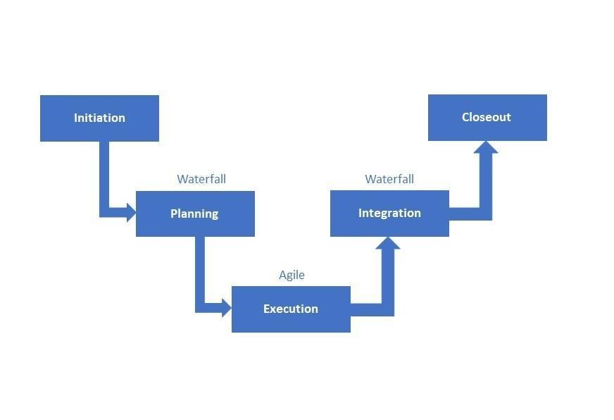

## 10.3. System Requirements Specifications

10.3.1. System Requirements for Development

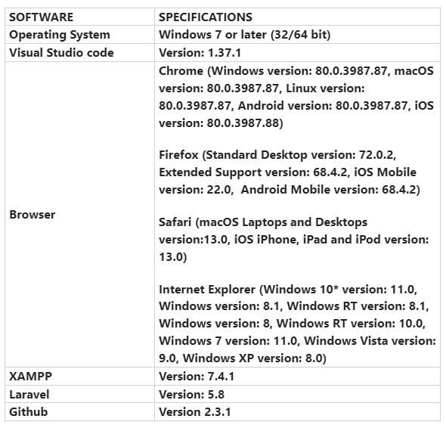

10.3.2. System Requirements for Deployment

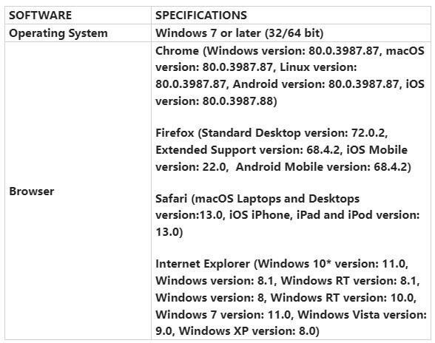

## 10.4. Development Tools Specification

10.4.1. Development Tools Specification

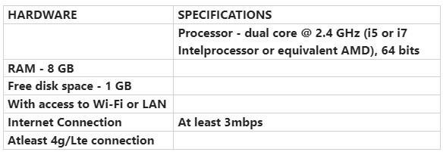

10.4.2. Deployment Tools Specifications

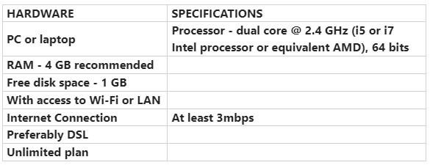

## 10.5. WBS Dictionary

|  |  |  |  |  |
| --- | --- | --- | --- | --- |
| **Level** | **WBS**  **Code** | **Element Name** | **Definition** | **Estimated Duration** |
| 1 | 1 | Dispatch Directory System | All work to implement a new    Dispatch Directory System. | - |
| **2** | **1.1** | **Initiation** | **The work to initiate the project.** | **44 days** |
| 3 | 1.1.1 | Evaluation & Recommendations | Working group to evaluate solution sets and make recommendations. | 5 days |
| 3 | 1.1.2 | Develop Project Charter | Project Manager to develop the Project Charter. | 35 days |

|  |  |  |  |  |
| --- | --- | --- | --- | --- |
| 3 | 1.1.3 | Deliverable: Submit Project  Charter | Project Charter is delivered to the Project Sponsor. | 1 day |
| 3 | 1.1.4 | Project Sponsor Reviews Project Charter | Project sponsor reviews the Project Charter. | 2 days |
| 3 | 1.1.5 | Project Charter Signed/Approved | The Project Sponsor signs the Project Charter which authorizes the Project  Manager to move to the Planning Process. | 1 day |
| **2** | **1.2** | **Planning** | **The work for the planning process for the project.** | **19 days** |
| 3 | 1.2.1 | Create Preliminary Scope Statement | Project Manager creates a Preliminary Scope Statement. | 4 days |
| 3 | 1.2.2 | Determine Project Team | The Project Manager determines the project team and requests the resources. | 5 days |
| 3 | 1.2.3 | Project Team Kickoff Meeting | The planning process is officially started with a  project kickoff meeting which  includes the Project Manager, Project Team, and Project Sponsor (optional). | 1 days |
| 3 | 1.2.4 | Develop Project Plan | Under the direction of the Project Manager the team develops the project plan. | 7 days |
| 3 | 1.2.5 | Submit Project Plan | Project Manager submits the project plan for approval. | 1 days |
| 3 | 1.2.6 | Milestone: Project Plan Approval | The project plan is approved, and the Project Manager has permission to proceed to  execute the project according to the project plan. | 1 days |
| **2** | **1.3** | **Execution** | **Work involved to execute the project.** | **122 days** |
| 3 | 1.3.1 | Project Kickoff Meeting | Project Manager conducts a formal kick off meeting with  the project team, project stakeholders and project sponsor. | 1 days |
| 3 | 1.3.2 | Verify & Validate User Requirements | The original user requirements are reviewed by the project manager and team, then validated with the | 9 days |

|  |  |  |  |  |
| --- | --- | --- | --- | --- |
|  |  |  | users/stakeholders. This is  where additional clarification may be needed. |  |

|  |  |  |  |  |
| --- | --- | --- | --- | --- |
| 3 | 1.3.3 | Design and Develop System | The technical resources design the new Dispatch  Directory System and install a    development system for  testing and customizations of user interfaces. | 74 days |
| 3 | 1.3.4 | Testing Phase | The system is tested with a select set of users. | 25 days |
| 3 | 1.3.5 | Install Live System | The actual system is installed and configured. | 9 days |
| 3 | 1.3.6 | User Training | All users are provided with job aides to understand how the new system works | 3 days |
| 3 | 1.3.7 | Go Live | System goes live with all users. | 1 day |
| **2** | **1.4** | **Control** | **The work involved for the control process of the project.** | **Throughout the project** |
| 3 | 1.4.1 | Project Management | Overall project management for the project. | Throughout the project |
| 3 | 1.4.2 | Project Status Meetings | Weekly team status meetings. | Weekly, every    Monday |
| 3 | 1.4.3 | Risk Management | Risk management efforts as defined in the Risk  Management Plan. | Throughout the project |
| 3 | 1.4.4 | Update Project Management Plan | Project Manager updates the  Project Management Plan as the project progresses. | Throughout the project |
| **2** | **1.5** | **Closeout** | **The work to close-out the project.** | **22 days** |
| 3 | 1.5.1 | Document Lessons Learned | Project Manager along with the project team performs a  lesson learned meeting and documents the lessons learned for the project. | 7 days |
| 3 | 1.5.2 | Update Files/Records | All files and records are updated to reflect the widget management system. | 5 days |
| 3 | 1.5.4 | Gain Formal Acceptance | The Project Sponsor formally accepts the project by signing | 1 day |
|  |  |  | the acceptance document included in the project plan. |  |
| 3 | 1.5.4 | Archive Files/Documents | All project related files and documents are formally archived. | 8 days |
| 3 | 1.5.5 | Project Close Out Meeting | Project Manager conducts a formal close out meeting with the project team, project stakeholders and project sponsor. | 1 day |

10.6 Detailed Schedule

|  |  |  |  |  |  |
| --- | --- | --- | --- | --- | --- |
| **TASK** | **START** | | | **END** | |
|  | **Dispatch Directory System** | | |  | |
|  | **Initiation** |  | |  | |
|  | Evaluation & Recommendations | 12/7/22 | | 12/14/22 | |
|  | Develop Project Charter | 12/15/22 | | 2/2/23 | |
|  | Submit Project Charter | 2/3/23 | | 2/3/23 | |
|  | Project Sponsor Reviews Project Charter | 2/3/23 | | 2/6/23 | |
|  | Project Charter Signed/Approved | 2/6/23 | | 2/6/23 | |
|  | **Planning** |  | |  | |
|  | Create Preliminary Scope Statement | 2/7/23 | | 2/10/23 | |
|  | Determine Project Team | 2/13/23 | | 2/17/23 | |
|  | Project Team Kickoff Meeting | 2/20/23 | | 2/20/23 | |
|  | Develop Project Plan | 2/21/23 | | 3/1/23 | |
|  | Submit Project Plan | 3/2/23 | | 3/2/23 | |
|  | **Project Plan Approval** | 3/3/23 | | 3/3/23 | |
|  | **Execution** |  | |  | |
|  | Project Kickoff Meeting | 3/6/23 | | 3/6/23 | |
|  | Verify & Validate User Requirements | 3/7/23 | | 3/17/23 | |
|  | Design System | 3/20/23 | | 7/7/23 | |
|  | Testing Phase | 7/10/23 | | 8/11/23 | |
|  | Install Live System | 8/14/23 | | 8/25/23 | |
|  | User Training | 8/28/23 | | 8/30/23 | |
|  | Go Live | 8/31/23 | | 8/31/23 | |
|  | **Control** |  | |  | |
| Project Management | | | 12/7/22 | | 9/29/23 |
| Risk Management | | | 12/7/22 | | 9/29/23 |
| Project Status Meetings | | | Weekly (every Monday) | | |
| Update Project Management Plan | | | 12/7/22 | | 9/29/23 |
| **Closeout** | | |  | |  |
| Document Lessons Learned | | | 9/1/23 | | 9/8/23 |
| Update Files/Records | | | 9/11/23 | | 9/15/23 |
| Gain Formal Acceptance | | | 9/18/23 | | 9/18/23 |
| Archive Files/Documents | | | 9/19/23 | | 9/28/23 |
| Project Close Out meeting | | | 9/29/23 | | 9/29/23 |

10.7 Detailed Cost Estimates

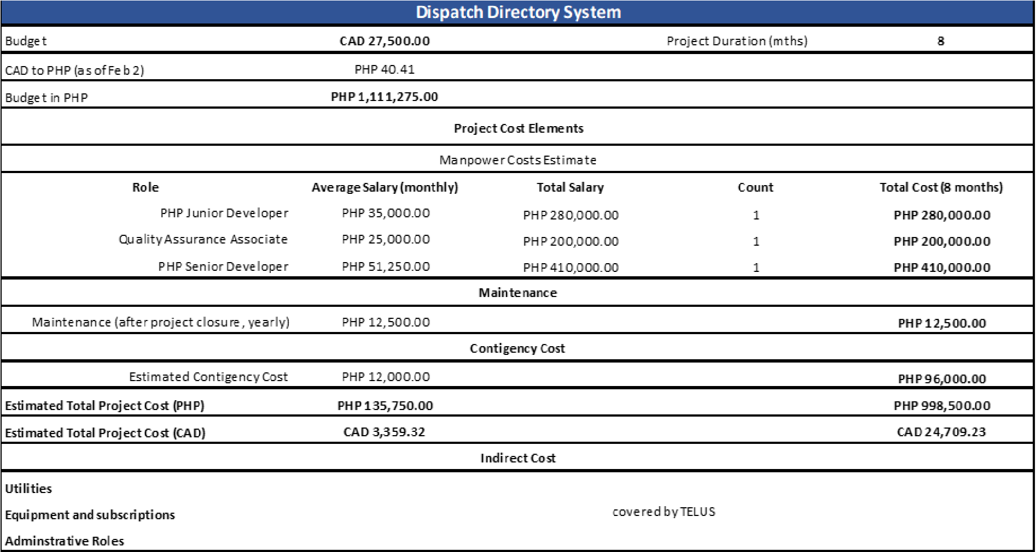

10.8 Handle Time

|  |  |  |  |  |  |
| --- | --- | --- | --- | --- | --- |
| **Outage #** | **Start** |  | **End** |  | **Duration** |

1 11:50:08 AM 1:20:53 PM 1:30 2 12:20:59 PM 1:20:53 PM 0:59 3 1:58:08 PM 2:38:06 PM 0:39 4 2:43:17 PM 3:22:59 PM 0:39 5 3:28:24 PM 3:37:21 PM 0:08 6 4:20:33 PM 4:22:21 PM 0:01 7 5:03:45 PM 5:19:45 PM 0:16 8 5:28:34 PM 5:33:20 PM 0:04 9 5:45:23 AM 5:47:36 AM 0:02 10 6:12:54 AM 6:14:21 AM 0:01 11 6:47:51 AM 6:50:15 AM 0:02 12 6:54:25 AM 6:55:03 AM 0:00 13 8:21:12 AM 8:32:53 AM 0:11 14 9:56:51 AM 10:13:35 AM 0:16 15 10:00:47 AM 10:03:49 AM 0:03 16 11:12:56 AM 11:17:13 AM 0:04 17 12:14:50 PM 12:28:39 PM 0:13 18 12:20:32 PM 12:23:15 PM 0:02 19 12:25:17 PM 12:32:44 PM 0:07 20 12:30:52 PM 12:37:40 PM 0:06 21 1:01:32 PM 1:01:53 PM 0:00 22 1:33:00 PM 1:47:24 PM 0:14 23 1:48:26 PM 2:13:12 PM 0:24 24 2:03:18 PM 2:21:59 PM 0:18 25 4:31:06 PM 4:35:49 PM 0:04 26 5:01:46 PM 5:06:35 PM 0:04 27 4:57:40 AM 4:58:37 AM 0:00 28 5:57:15 AM 6:00:35 AM 0:03 29 9:00:46 AM 9:02:08 AM 0:01 30 10:05:35 AM 10:07:51 AM 0:02 31 10:43:55 AM 10:47:02 AM 0:03 32 1:23:31 PM 1:34:51 PM 0:11 33 1:40:12 PM 1:54:27 PM 0:14 34 2:04:09 PM 2:21:49 PM 0:17 35 2:41:54 PM 2:44:24 PM 0:02 36 3:06:18 PM 3:48:19 PM 0:42 37 3:22:31 PM 3:27:20 PM 0:04 38 3:44:23 PM 3:53:04 PM 0:08 39 4:32:13 PM 4:46:54 PM 0:14 40 4:55:05 PM 5:04:26 PM 0:09 41 5:05:45 PM 5:17:00 PM 0:11 42 5:33:56 PM 5:44:05 PM 0:10 43 12:46:10 AM 12:48:13 AM 0:02 44 1:12:40 AM 1:15:09 AM 0:02 45 1:59:55 AM 2:08:58 AM 0:09 46 6:16:03 AM 6:17:06 AM 0:01 47 7:09:29 AM 7:10:47 AM 0:01 48 8:17:40 AM 8:22:54 AM 0:05 49 8:21:10 AM 8:24:59 AM 0:03 50 9:30:15 AM 9:33:18 AM 0:03

|  |  |  |  |
| --- | --- | --- | --- |
| **Outage #** | **Start** | **End** | **Duration** |

51 9:59:24 AM 10:05:56 AM 0:06 52 10:03:16 AM 10:04:37 AM 0:01 53 11:58:20 AM 11:58:27 AM 0:00 54 10:16:34 AM 10:44:31 AM 0:27 55 10:30:39 AM 10:33:32 AM 0:02 56 10:57:18 AM 10:58:49 AM 0:01 57 11:02:01 AM 11:04:55 AM 0:02 58 11:14:09 AM 11:21:12 AM 0:07 59 12:08:32 PM 12:17:45 PM 0:09 60 12:30:44 PM 12:35:40 PM 0:04 61 12:45:07 PM 12:46:16 PM 0:01 62 1:28:31 PM 1:34:26 PM 0:05 63 1:48:33 PM 1:51:44 PM 0:03 64 2:29:49 PM 2:40:48 PM 0:10 65 3:16:00 PM 3:21:48 PM 0:05 66 4:22:49 PM 4:27:11 PM 0:04 67 4:32:47 PM 4:35:35 PM 0:02 68 4:52:27 PM 4:56:18 PM 0:03 69 5:01:05 PM 5:03:45 PM 0:02 70 5:06:42 PM 5:16:47 PM 0:10 71 5:09:13 PM 5:11:34 PM 0:02 72 5:11:46 PM 5:16:12 PM 0:04 73 5:15:11 PM 5:17:29 PM 0:02 74 5:20:30 PM 5:32:17 PM 0:11 75 5:24:11 PM 5:28:13 PM 0:04 76 5:31:14 PM 5:35:34 PM 0:04 77 5:37:15 PM 5:47:13 PM 0:09 78 5:43:14 PM 6:02:34 PM 0:19 79 5:48:22 PM 5:56:15 PM 0:07 80 5:52:47 PM 5:55:40 PM 0:02 81 6:14:21 PM 6:16:54 PM 0:02 82 6:19:15 PM 6:22:13 PM 0:02 83 6:42:00 PM 6:44:54 PM 0:02 84 6:52:02 PM 7:14:41 PM 0:22 85 6:54:12 PM 6:58:25 PM 0:04 86 6:54:16 PM 7:00:43 PM 0:06 87 7:03:08 PM 7:06:46 PM 0:03 88 8:55:41 PM 8:58:55 PM 0:03 89 9:01:08 PM 9:05:38 PM 0:04 90 9:44:07 PM 9:48:07 PM 0:04 91 7:24:52 AM 7:33:30 AM 0:08 92 8:16:22 AM 8:24:32 AM 0:08 93 8:32:51 AM 8:41:20 AM 0:08 94 8:45:17 AM 8:49:05 AM 0:03 95 9:33:19 AM 9:37:03 AM 0:03 96 9:39:34 AM 9:57:33 AM 0:17 97 10:38:35 AM 10:40:06 AM 0:01 98 10:48:22 AM 10:50:41 AM 0:02 99 1:10:44 PM 1:12:46 PM 0:02

1. 1:21:10 PM 1:22:48 PM 0:01

|  |  |  |  |  |  |
| --- | --- | --- | --- | --- | --- |
| **Outage #** | **Start** |  | **End** |  | **Duration** |

1. 2:26:50 PM 2:31:53 PM 0:05 102 3:39:15 PM 3:42:41 PM 0:03 103 3:50:02 PM 3:59:39 PM 0:09 104 4:01:06 PM 4:04:40 PM 0:03 105 4:14:53 PM 4:20:32 PM 0:05 106 4:51:23 PM 4:58:07 PM 0:06 107 4:59:42 PM 5:05:36 PM 0:05 108 8:51:03 PM 8:57:22 PM 0:06 109 7:37:54 AM 7:41:27 AM 0:03 110 8:14:44 AM 8:22:40 AM 0:07 111 9:29:13 AM 10:20:55 AM 0:51 112 10:21:00 AM 10:23:14 AM 0:02 113 10:30:51 AM 10:32:38 AM 0:01 114 10:46:23 AM 10:53:15 AM 0:06 115 11:06:27 AM 11:08:28 AM 0:02 116 11:50:42 AM 12:12:34 PM 0:21 117 12:35:24 PM 12:40:07 PM 0:04 118 1:18:01 PM 1:50:53 PM 0:32 119 2:02:54 PM 2:14:44 PM 0:11 120 4:17:21 PM 4:32:26 PM 0:15 121 4:41:06 PM 4:48:24 PM 0:07 122 5:39:09 PM 5:42:58 PM 0:03 123 5:58:32 PM 6:00:39 PM 0:02 124 10:18:37 AM 10:27:28 AM 0:08 125 10:51:21 AM 10:53:24 AM 0:02 126 11:40:10 AM 11:41:51 AM 0:01 127 12:50:26 PM 1:10:49 PM 0:20 128 4:13:44 PM 4:31:49 PM 0:18 129 6:29:12 PM 6:55:35 PM 0:26

**Average** **0:09**